

**Module: Advance Computer Science Masters Project**

**Course Code: 7COM1086-0109-2020**

**Topic – Automatic Number Plate Recognition System**

**Guided by – Dr. Manal Helal**

**Module Leader – Dr. Helen Xiang**

**Submitted by: Abhishek Bhandare**

*Department of computer science, University of Hertfordshire, Hatfield, United Kingdom.*

Table of Contents

Table of Figures: 4

List of Tables: 4

ABSTRACT 5

CHAPTER 1: INTRODUCTION 6

1.1 ABOUT AUTOMATIC NUMBER PLATE RECOGNITION (ANPR) 6

1.2 WORKING OF AN ANPR SYSTEM 7

1.3 CHALLENGES WITH DEVELOPMENT OF AN ANPR SYSTEM 8

1.4 BENEFITS OF ANPR SYSTEM 8

1.5 HOW TO IMPROVISE ANPR? 9

1.6 STEPS IN AUTOMATIC NUMBER PLATE RECOGNITION 11

CHAPTER 2: LITERATURE REVIEW 13

2.1 BACKGROUND 13

2.2 REVIEW OF LITERATURE 14

CHAPTER 3: METHODS 16

3.1 DATA SET – 16

3.2 DATA COLLECTION AND CREATION – 16

3.3 MODEL SELECTION AND RESEARCH – 16

3.3.1 WHAT IS MOBILENET V2 – 16

3.3.2 MOBILENET V1 VS MOBILENET V2 – 17

3.3.3 MOBILENET V2 ARCHITECTURE – 18

3.3.4 DIFFERENT TYPES OF CONVOLUTION LAYERS – 19

3.3.5 WORKING OF A MOBILENET V2 – 22

3.3.6 ADVANTAGES OF A MOBILENET V2 – 25

3.4 OPTICAL CHARACTER RECOGNITION – 25

3.4.1 EASYOCR – 25

CHAPTER 4: EXPERIMENTATION & ANALYSIS 26

3.1 INTRODUCTION 26

To train our model, we utilised the TensorFlow Object Detection Model. The test images were found using Kaggle. EasyOCR was used to simplify OCR.The entire code will be written in Jupyter Notebook. 26

3.2 TENSORFLOW OBJECT DETECTION – MOBILENET V2 26

3.2.1 SETTING UP PATHS AND DOWNLOADING MODEL 26

3.2.2 TRAINING MODEL 28

CHAPTER 4: RESULTS 30

4.1 INTRODUCTION 30

4.2 EVALUATION OF THE MODEL 30

4.2.1 EVALUATION OF MODEL 1 30

4.2.2 EVALUATION OF MODEL 2 33

4.3 OCR TEST RESULTS 38

4.4 Real Time Detections with webcam – 42

CHAPTER 5: CONCLUSION & FUTURE SCOPE 43

5.1 FUTURE SCOPE 43

5.2 CONCLUSION 43

REFERENCES 44

APPENDIX: 48

# Table of Figures:

Figure 1 An automatic plate recognition system working in a parking lot 7

Figure 2 OCR Application of ANPR System 12

Figure 3 Mobile Net V1 vs Mobile Net V2 17

Figure 4 Mobile Net V2 Block Diagram 19

Figure 5 1*1 Convolution 20

Figure 6 Spatial Separable Convolutions 20

Figure 7 Depthwise Convolution 21

Figure 8 Pointwise Convolution 22

Figure 9 Main Building Bolck of MobileNet V2 23

Figure 10 Example of a bottleneck residual connection 24

Figure 11 ReLU6 activation function 24

Figure 12 Annotations giving coordinates for Region of Interest 27

Figure 13 Lebel Map 27

Figure 14 Updating Indexing in GenerateTFRecord 28

Figure 15 Training MobileNet V2 and loss results at 10,000 steps 29

Figure 16 Total loss for model 1 30

Figure 17 Classification loss of the model 1 31

Figure 18 Localization loss of Model 1 31

Figure 19 Learning Rate of Model 1 32

Figure 20 Steps per second of model 1 32

Figure 21 Total loss of model 2 33

Figure 22 Evaluation Matrics of Model 2 34

Figure 23 Classification loss of Model 2 34

Figure 24 Localization loss of Model 2 35

Figure 25 Learning rate of Model 2 36

Figure 26 Steps per second of Model 2 36

Figure 27 Training Results Model 2: Accuracy: 85% 38

Figure 28 OCR detections of detected image 1 39

Figure 29 OCR All Results 39

Figure 30 OCR result after detection and region threshold 40

Figure 31 Evaluation result of Image 2 - 90% accuracy 40

Figure 32 Detected image 41

Figure 33 Real Time Detection with 80% Accuracy 42

# List of Tables:

Table 1 Comparison between ANPR system and an RFID system 11

Table 2 The key technical features of both the models 37

# ABSTRACT

In our project entitled “Automatic Number Plate Recognition (ANPR)”, we aim to develop a system that could be used to detect and get the characters of the number plate in textual format. ANPR (Automatic Number Plate Recognition) has significant advantages. As indicated by measurements of the International Association of Chiefs of Police, up to 70% of genuine wrongdoing is connected to the burglary of engine vehicles or their utilization in perpetrating violations. Examinations and insights show that ANPR frameworks are especially helpful in finding taken vehicles and missing people, and in researching thefts and kidnappings. There are several benefits associated with an automatic license plate reading such as continuous and automatic scanning of vehicles from the back, nearby, and front and during the time of night and day. There are a different number of cameras are fitted which is based on the requirements of the customer, a tablet or mobile can read the license plates, and finally, it can recognize the next lane irrespective of the direction of the vehicle. This report explains neural network and image processing and they can be used effectively for this task which is automatic license plate reading. We have used Jupyter Notebook for our implementation along with some key libraries of Python for the detection of number plates. The problem statement of the considered system is explained in this report along with, the scope of the project and the outline of the methodology.

# CHAPTER 1: INTRODUCTION

Technologies for smart cars, smart cities, and smart transportation systems continue to change many aspects of human life. Therefore, technologies like Automatic License Plate Recognition (ANPR) have become part of our daily activities. Additionally, the ANPR concept is expected to contribute to various use cases while eliminating human intervention.

We have divided our report into five Chapters.

Chapter 1 contains the introduction portion. We provide information about what do we mean by an automatic number plate recognition system and the basic process behind it. Also, we have discussed the benefits of the same. The challenges that are possible while making such a system are also discussed.

Chapter 2 contains the literature survey. We have conducted a detailed literature review on this topic. There have been a lot of work done in this domain. We have limited our literature survey to the past 10 years.

Chapter 3 contains the analysis and the design portion. We have described how we aim to detect the objects, the model training, and the complete implementation. Flowcharts have been placed for a better understanding of our implementation.

Chapter 4 contains the results. We have described the results of our implementation here. All results, including the model evaluation, model training, and OCR have been shown.

Chapter 5 contains the conclusion. We have described the future scope and concluded our work in this chapter.

## ABOUT AUTOMATIC NUMBER PLATE RECOGNITION (ANPR)

Automatic number plate recognition is a computer vision practice that allows the device to automatically read the vehicle's license plate quickly without any manual intervention. Therefore, ANPR is used to accurately capture and recognize any license plate by using video clips or photos from the camera.

Automatic Number Plate Recognition (ANPR), also known as Automatic License Plate Recognition (ALPR), is software that automatically recognizes license plates by performing complex optical character recognition on images to read vehicle license plates (Farhat, et al., 2018).

A typical ANPR solution takes an image as input and returns the decoded license plate, timestamp, and confidence of the decoding algorithm. The image analysis speed can be as fast as 20 to 50 milliseconds for real-time monitoring.

Fig. 1 shows a typical system detection of license plates.

The ANPR system mainly has components like a Camera System, GateREG, etc. GateREG is a sort of new component of the ANPR systems under networking.

GateREG wisely screens moving toward vehicles, coordinating with the enrolment numbers with the data in its inbuilt restrictive data set and showing chosen subtleties, for example, vehicle model, driver's name, and picture.

GateREG has been broadly taken on by open area and blue-chip organizations who have profited from utilizing vehicle information to screen and oversee approved and unapproved guests.

The advantages of this framework are:

* Effective control and the executives of your guests' entrance across various destinations
* Exact recognizable proof of vehicles and drivers with excellent pictures
* Capacity to log and discover point by point data on each vehicle entering your premises
* Augmented security by cautioning staff and limiting access for 'boycotted' vehicles

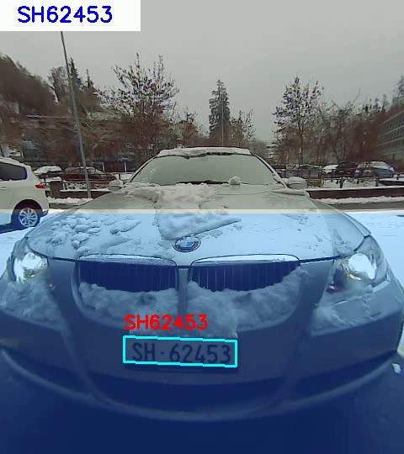

Figure 1 An automatic plate recognition system working in a parking lot

## WORKING OF AN ANPR SYSTEM

ANPR is one of the most accurate applications of computer vision systems. Automatic license plate recognition systems use Optical Character Recognition (OCR) to read vehicle license plates. The camera takes a high-speed image of the license plate and image processing software is used to detect characters, verify the character sequence, and convert the license plate image to text.

A typical ANPR system includes a digital image capture unit (camera), a processing unit, and different algorithms for video analysis. Additionally, the use of infrared lighting allows such systems to capture vehicle license plates at night, allowing ANPR to operate at all times of the day.

The work can be simply described in three steps. These are (Gunawan, Mutholib, & Kartiwi, 2017):

· First, the ANPR camera captures images containing license plates (video footage or photos).

· Then use machine learning and computer vision processes to detect the license plate (object detection)

· Finally, apply OCR software to the detected license plate area and return the license plate number in text format. The converted number is generally stored in a database for integration with other IT systems.

## CHALLENGES WITH DEVELOPMENT OF AN ANPR SYSTEM

The automatic license plate/license plate recognition system has various shapes and sizes (Rosebrock, 2020):

* ANPR is executed under controlled lighting conditions, the type of license plate is predictable, and basic image processing techniques can be used.
* Somewhat better and a bit complex ANPR system uses dedicated object detectors, such as Histogram of Oriented Gradients (HOG) + linear Support Vector Machine (SVM), Faster Region-Based Convolutional Neural Networks (RCNN), Signal Stage Object Detection (SSD), and You Only Look Once (YOLO), to locate the license plate in the image. All these are specific methods and libraries.
* The most up-to-date technology to enhance the OCR of the text in the section, ANPR software employs Recurrent Neural Networks (RNN) and Long Short-Term Memory Networks (LSTM).

Even the most modern ANPR system pre-processes and cleans pictures before OCRing, enhancing ANPR accuracy. Because it may be necessary to work in real-time, automatic license plate/license plate recognition becomes more difficult.

Consider the implementation of the ANPR framework on a highway. It should be able to recognize each passing vehicle's tag, conduct OCR on the tag characters, and then save this information in the data set so that the owner may compile the expenses. Finding a dataset that may be used to create a bespoke ANPR model is one of the many increasing variables that make ANPR so helpful! The massive and amazing ANPR informational collections needed to create the most extraordinary models are tightly guarded and are rarely, if ever, freely released (Rosebrock, 2020):

* These data sets include personally identifiable information on cars, drivers, and their locations.
* Annotating ANPR data sets is time-consuming and requires a lot of man-hours.
* Local and federal government ANPR contracts are frequently very competitive. As a result, the data set picked by a firm is generally more useful than the trained model.

Therefore, you will see that the ANPR company obtains it not through your ANPR system but through the data itself.

## BENEFITS OF ANPR SYSTEM

ANPR offers many advantages, which are the basis for practical applications. Most of ANPR's benefits come from automating manual tasks, efficient space management, governance, and improving the customer experience.

Some of the key benefits of such a system are mentioned below (Khaparde, Detroja, Shah, Dikey, & Thakare, 2018):

* The automatic recognition of license plates allows automatic notification and control of facilities. Therefore, ANPR is a key technology for smart cities.
* The data generated can be used for traffic flow analysis. This is particularly important for the operation of Intelligent Transportation Systems (ITS), where data processing technology is used to improve the mobility of people and goods, manage demand, improve safety, reduce traffic congestion, and effectively manage traffic incidents.
* Fast identification of vehicle license plates is the basis for quick and easy identification. Identity recognition can be used to grant vehicle access or to find and track specific vehicles.
* Accurate and fast license plate recognition does not rely on human intervention. Therefore, it promotes profitable governance and reduces waiting time.
* ANPR typically integrates with other IT systems and runs in an ecosystem, providing a simple and seamless experience for end-users. Therefore, technology is used to improve the customer experience and provide new services and products, such as automatic parking payments.

Automatic license plate recognition is essential for a wide range of applications, where vehicle detection, recognition, or positioning is very important.

* Police departments utilize ANPR for a variety of objectives, including confirming vehicle registration and detecting cars involved in traffic offenses. Authorities can identify cars and follow their position using the capacity to detect and recognize license plates in real-time.
* Parking management requires an integrated solution to detect individual vehicles. Therefore, automatic license plate recognition is the key to efficient parking management. ANPR allows automatic management of parking in parking lots because each vehicle is calculated based on its license plate number. Therefore, parking lot users avoid the pressure of managing their fines and tracking the time spent and avoid the risk of fines for paying inaccurate fines or losing them. Also, if there is a disagreement, you can check out this automatic follow-up. Such a parking system will track all vehicles on the premises and ensure complete management.
* Journey Time Analysis (JTA) is an important application for authorities to identify passing vehicles and their time from one node to another. In addition, these analyses can provide better route planning for traffic managers.
* traffic management is a general term for the many benefits provided by ANPR. ANPR can be used in all cities to detect speeding vehicles, crashing vehicles, or any accidents. ANPR provides solutions for measuring and analyzing traffic data related to specific areas or entire cities. On a larger scale, traffic management provides insight into traffic congestion for better traffic planning.
* Business parks often face unauthorized parking, causing problems for legal parking spaces or sometimes suspicious activities. By ensuring that only authorized vehicles can use parking spaces, ANPR technology can address such safety risks. Manual management of
* Expressway toll stations are still an important practice in some parts of the world. Toll stations usually use different technologies for autonomous toll station management. For example, on larger highways, ANPR allows authorities to receive license plate numbers to pay tolls by mail or automatically, rather than stopping and paying at manually operated toll booths. Therefore, ANPR can achieve efficient toll station management, reduce required operating time, and thus increase productivity.

## HOW TO IMPROVISE ANPR?

There are a few suggestions which would enable us to have higher accuracy with the software. These are (Plate Recogniser, 2021):

* We will see nearly undetectable pictures of the car depending on the camera and/or video management software (VMS) utilized. This might be because the motion detection is overly sensitive, or the camera and/or VMS are taking photos when motion is detected. Setting a little delay while capturing the photograph is all it takes to solve this problem. As a result, rather than taking the photograph right away, wait 0.5 seconds to make the car stand out. As a result, the license plate will display more prominently in the ANPR engine photographs.
* • Make sure the ANPR camera is focused on the approaching license plate. The camera in front of the parking lot, rather than aiming at the entry or departure area, is frequently seen pointing at the whole parking lot. Again, the fix is simple: simply change the camera's location and focus to make the license plate more visible.
* In terms of deciphering license plates in low-light conditions, the ANPR engine has gone a long way. In certain situations, however, the headlamps were unable to identify the existence of license plates. We would need to light the entry/exit locations or utilize a camera with a wider aperture to overcome this problem.

Automatic Number Plate Recognition (ANPR) is a framework that is capable of reading vehicle license plates quickly and without the need for human intervention. It examines the human groups and recognizes the characters from the captured picture of the car number plate. It's appropriate for character recognition that turns an image into a message. Car Plate Recognition (CPR), License Plate Recognition (LPR), Automatic Vehicle Identification (AVI), and Automatic License Plate Recognition (ALPR) are all terms used to describe this technology.

It is a technology that is used to locate a car permit/number plate and send the data to the next step for PC processing, where it may be decoded, saved, and used for a variety of reasons. Many police forces are employing this technology to track criminal activity as well as to identify speeding cars at specific locations. It has used electronic cost collection on roadways where people pay for each visit and for traffic monitoring.

RFID, or Radio Frequency Identification, refers to a technology in which information is meticulously encoded in the form of RFID labels, and a peruser is used to identify this information via radio waves. This data is then used for new capabilities with minimal human intervention. When the RFID label interacts with the user, it sends out radio signals, which the user then converts into useful information.

The comparison among both the technologies is elaborated in the Table 1 (Kaur H. , 2019).

|  |  |  |
| --- | --- | --- |
| Property | ANPR | RFID |
| Equipment | This technique utilizes some infrared cameras programmed with optical character readers. | This technique uses RFID tags along with a reader. |
| Applying Criteria | Vehicles need to have a number plate by default. | A special tag needs to be placed on the vehicle. |
| Hindrance | There could be dirt, various shapes of number plates, different languages, broken plates etc. that could hinder the detection. | Practically zero chance of hindrance. |
| Environmental Issues | Functionality issues during fog, glares etc. The Camera itself might be dirty. | Functions easily in dirt and fog as well. |
| Accuracy | Roughly around 70 to 85 percent on basis of shapes etc. | Roughly greater than 99.5 percent. |
| Managing | Many cameras are required for different lanes | Two lanes could be managed via a single reader. |

Table 1 Comparison between ANPR system and an RFID system

After intently inspecting the upsides and downsides of both the RFID and ANPR innovation, it is all in all correct to build up that RFID ends up being more productive and reliable for stopping and costs though ANPR can be utilized to upgrade the security.

## STEPS IN AUTOMATIC NUMBER PLATE RECOGNITION

The ANPR procedure necessitates the use of specific algorithms and methodologies. However, there are four important phases in the automatic license plate identification process:

* Catching the vehicle's picture – It includes catching pictures of a vehicle (counting its number plate) utilizing reconnaissance cameras. Since legitimate picture quality is an absolute necessity for the subsequent advance.
* Number plate location – The calculations get the preparation to break down high differentiation regions to discover tags. The framework transforms caught pictures into dim scale pictures. This is called binarization. Then, at that point commotion is eliminated from the picture. This cycle helps in the third step.
* Character division – This stands as a passage for appropriate outcomes. Characters not appropriately sectioned can wind up breaking into two portions. Along these lines, calculations predominantly utilize neural organizations for this cycle. In addition, character division happens in two stages. Right off the bat, utilizing level division (normal methodology). Furthermore, utilizing vertical division. This totally relies upon how the numbers are set.
* Character acknowledgment – So presently comes the last advance. It incorporates perceiving the characters from the sectioned picture. This cycle is called highlight extraction. Information change occurs from bitmap portrayals. This information is changed into descriptors (reasonable for PCs). Vectors of numeral qualities which depict a specific person are called descriptors.

Fig. 2 shows the OCR application of the APNR system.

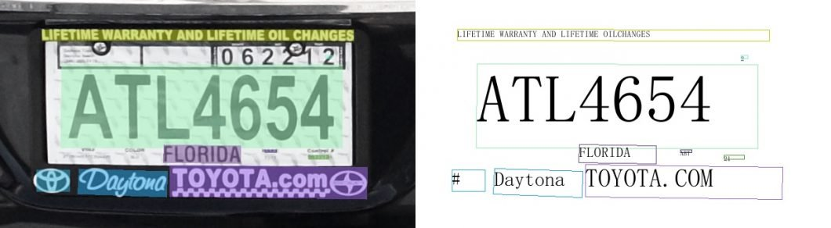

Figure 2 OCR Application of ANPR System

# CHAPTER 2: LITERATURE REVIEW

## 2.1 BACKGROUND

In this section, we shall discuss the algorithms mentioned in our work.

Convolutional Neural Networks (CNN) is an acronym for convolutional neural networks. Convolutional Neural Network (CNN / ConvNet) is a form of deep neural network used to analyze visual pictures in deep learning. When we think about neural networks, we usually think of matrix multiplication; however, this is not the case with ConvNet. It employs a method known as convolution. Convolution is a mathematical action on two functions in mathematics. It generates a third function that demonstrates how the form of one function is influenced by the shape of another.

RNN stands for Recurrent Neural Networks. Recurrent Neural Network (RNN) is the most advanced data stream algorithm used by Apple's Siri and Google's voice search. Due to internal memory, it is the first algorithm to remember your input, making it well suited for machine learning problems involving sequence data.

Long short-term memory, or LSTM, is a component of RNNs. A recurrent neural network that can learn the order dependency of sequence prediction issues is the long short-term memory (LSTM) network. In complicated problem domains like machine translation and speech recognition, this is a required behavior. Deep learning using LSTMs is a complicated area.

The core of neural network training is backpropagation. It is the process of changing the weight of the neural network based on the preceding period's error rate (or loss) (that is, iteration). Correctly fitting the weights can ensure a low error rate and make the model reliable by improving generalizability.

The full form of OCR is Optical Character Recognition. It is a broad innovation to perceive text inside pictures, like checked archives and photographs. OCR innovation is utilized to change over practically any sort of picture containing composed text (composed, transcribed, or printed) into machine-comprehensible text information. In general terms, the recognition is based on a complete set of technologies and processes, and should not be considered limited to the information that characterizes the target at a technical level, such as the versions of the hardware or software components used.

SVM stands for Support Vector Machine. The Support Vector Machine (SVM) is a supervised machine learning model that solves two sets of classification problems using classification methods. They may categorize the incoming text after giving an SVM model with a labeled training data set for each category.

## 2.2 REVIEW OF LITERATURE

Keong & Iranmanesh (2016), created a Pearson correlation-based automatic number plate recognizer for Malaysia. The Automatic License Plate Recognition (ANPR) framework helps screen and track countless tags by perusing tags as information and naturally perceiving tag characters as yield. Indeed, mistaken acknowledgment might be brought about by an assortment of elements, for example, plate pivot and non-uniform enlightenment during picture procurement. The repairing activity and format coordinating with innovation are proposed in this piece to preserve the car plate precision to a substantial degree. A proposed system achieves an overall accuracy of 91.1% during the system identification process (Keong & Iranmanesh, 2016).

Puranic et. al. (2016), created a number plate recognition system for vehicles through template matching technique as well as conducted a literature analysis on this. The increasing influx of Indian cities makes car ownership a necessity. As a result, there was an unanticipated municipal issue with traffic management and car identification. As the number of vehicles on today's roads continues to increase, parking areas have become overloaded. Because its applications vary from parking and access to city traffic monitoring and auto theft tracking, the Automatic License Plate Recognition System (ANPR) plays an essential role in tackling these challenges. Currently, a variety of ANPR systems based on various techniques are available. The writers attempt to evaluate numerous technologies and their applications in this article. The ANPR technology uses template matching, and Indian license plates have an accuracy rate of 80.8 percent (Puranic, Deepak, & Umadevi, 2016).

Kumar et. al. (2016), proposed an efficient technique for the recognition of number plates for low-resolution images. Notwithstanding created nations, many agricultural nations are confronting inward and outside security outrage. Lacking assets power these nations to embrace Automatic License Plate Recognition (ANPR) to further develop security partially. For manual observation, some countries employ CCTV cameras. These CCTV cameras are meant to function with the planned ANPR architecture. Picture improvement, character division, and character acknowledgment are the three most important aspects of a film. The primary goal of this project is to innovate each of these components. The proposed method has been tested on both high- and low-goal images. In low-goal images, the suggested approach achieves a 96.2 percent accuracy in character recognition and a 100 percent accuracy in character division, but other current technologies are unable to detect tags. In top-notch pictures, the proposed strategy accomplishes 100% precision in character division and 95.3% normal exactness in character acknowledgment. As far as character division of top-notch pictures, this strategy is 4.5% higher than other existing strategies (Kumar, Gupta, & Kushwaha, 2016).

Mondal et. al. (2017), created an automatic number plate recognition system based on the CNN and self-learning model. Image processing has been the focus of a variety of real-world applications in today's image-centric environment. Starting to steal cars, violating traffic rules, and violating restrictions on extensions, image processing has given us the belief to end these misconducts. Its noteworthy achievement is the identification of license plate numbers and picture recognition, which is done using Convolutional Neural Networks (CNN), which are inspired by the functional learning capabilities of Convolutional Neural Networks (CNN) (CNN). License plate photos may be captured with a still camera. Even if the training scale is extremely tiny, CNN's automated synthesis function can determine the condition of the vehicle from the license plate with high accuracy of 90%. Even on distorted, slanted, and illuminated data sets, CNN has proven its strength (Mondal, Mondal, Saha, & Chattopadhyay, 2017).

Kulkarni et. al. (2018), created an automatic number plate identification system for motorists who do not wear a helmet when driving. In poor nations, motorcycles have traditionally been the primary means of transportation. Motorcycle accidents have become more common in recent years. Motorcycle riders who do not wear protective helmets are one of the major causes of mortality in accidents. The most frequent technique for traffic cops to guarantee that motorcyclists wear helmets is to manually watch them at intersections or to use closed-circuit television footage to catch those who don't. It does, however, need human interaction and effort. This paper presents an automated approach for detecting motorcycle riders who are not wearing helmets and retrieving their license plates from CCTV pictures. To acquire moving items, the suggested approach first removes the video's backdrop. Motorcyclists and non-motorcyclists are then categorized as moving objects. The head is connected and categorized as a helmet or no helmet for classified motorcyclists. Finally, for identified riders who do not wear a helmet, the motorcycle's license plate is detected, and the characters on it are extracted in text form. The system proposed by the authors uses a convolutional neural network trained by migration learning on a pre-trained model for classification, which helps to achieve higher accuracy. The experimental results in the traffic video show that the detection accuracy of motorcycle riders without helmets is 98.72% (Kulkarni, Bodkhe, Kamthe, & Patil, 2018).

# CHAPTER 3: METHODS

## 3.1 DATA SET –

For the detection of the license plate of the car and bike, a dataset of 833 images is used. The dataset contains the bounding box annotations in the PASCAL VOC format. The bounding box annotation has only one class named ‘license’. The bounding box annotation provides a dimension of images and bounding box. In this dataset, a bounding box is marked around the license plate of a vehicle. The images with bounding box annotation were downloaded from Kaggle ([https://www.kaggle.com/datasets/andrewmvd/](https://www.kaggle.com/datasets%20/andrewmvd/)[car-plate-detection](https://www.kaggle.com/datasets/andrewmvd/car-plate-detection)). To increase the dataset more images were added.

## 3.2 DATA COLLECTION AND CREATION –

Research for the dataset was carried out for different image formats with bounding box annotation. Bounding box annotation is the area marked around the object by tools like LebellImg. The bounding box provides the coordinates of an object within an image. The online image searching platforms like roboflow made it easy to collect an image for our dataset to detect the license plate of vehicles. Initially, 800 images were collected, and then 400 images were selected for further annotation marking based on image quality and considering different angles and visibility conditions. The annotation around license plates was marked and saved as a PASCAL VOC format under the class name ‘license’. Then 87 images were selected for testing and 749 images were selected for training a MobileNet V2 model.

## 3.3 MODEL SELECTION AND RESEARCH –

In this experiment, we aim to detect a license plate of a vehicle and be able to recognize characters from the license plate. Many research papers have been reviewed to find the best suitable method among all for this experiment. A classification model created by Google is known as MobileNet V2. This model provides real-time classification abilities for devices with limited computation power, such as cellphones. The ability to run deep neural networks on personal mobile devices enhances user experience by allowing users to access information at any time and from any location, as well as providing security, privacy, and energy savings.

## 3.3.1 WHAT IS MOBILENET V2 –

MobileNets are low-latency, low-power models that have been parameterized to meet the resource constraints of different use cases. According to the study report, MobileNetV2 improves the region performance of mobile models on a variety of tasks and benchmarks, as well as across a range of model sizes. It is a sophisticated feature extractor for object detection and segmentation. For example, when used with Single Shot Detector Lite, MobileNetV2 is approximately 35% faster and has the same accuracy as MobileNetV1.

It extends MobileNetV1's concepts by utilizing depth-wise separable convolutions as efficient building pieces (Sinha, 2022). Google, on the other hand, claims that the second edition of MobileNet offers two new features:

* Data from experiments demonstrate that using linear layers is crucial because it prevents nonlinearities from eliminating too much information. Using non-linear layers at bottlenecks decreases performance by several percent, supporting our forecast.
* Shortcut connections between bottlenecks.

## 3.3.2 MOBILENET V1 VS MOBILENET V2 –

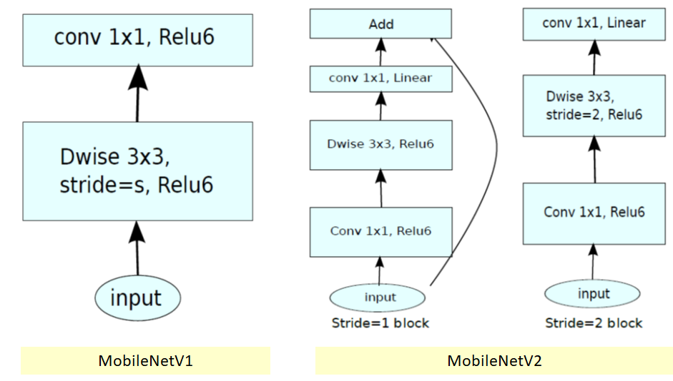

Figure 3 Mobile Net V1 vs Mobile Net V2

**1] MobileNet V1:**

* There are two layers in MobileNetV1.
* The first layer, known as depthwise convolution, applies a single convolutional filter per input channel to conduct lightweight filtering.

The second layer is a pointwise convolution (11 convolutions), which is responsible for creating new features by computing linear combinations of the input channels (Review: MobileNetV2 — Light Weight Model (Image Classification), 2022) .

**2] MobileNet V2:**

* There are two sorts of blocks in MobileNetV2. One is a one-stride residual block. Another option for downsizing is a block with a 2 stride.
* Both sorts of blocks have three levels.
* The first layer is 11 convolutions using ReLU6 this time.
* The depthwise convolution is the second layer.
* Another 11 convolutions are used in the third layer, but this time there is no non-linearity. If ReLU is applied again, deep networks will only have the power of a linear classifier on the non-zero volume part of the output domain, according to the hypothesis.
* There is also a t is an expansion factor. For all of the primary experiments, t=6 was used. The internal output would have 64*t=64*6=384 channels if the input had 64 channels (Review: MobileNetV2 — Light Weight Model (Image Classification), 2022).

## 3.3.3 MOBILENET V2 ARCHITECTURE –

**Basic Structure -** The MobileNetV2's bottlenecks encode the model's ability to transform from lower-level concepts like pixels to higher-level descriptors like image categories, while the inner layer encapsulates the model's ability to transform from lower-level concepts like pixels to higher-level descriptors like image categories. Shortcuts provide faster training and improved accuracy with standard residual connections (Sinha, 2022).

The architecture of MobileNet V2 has been thoroughly examined. The MobileNet V2 model comprises 53 convolution layers and a single AvgPool with a GFLOP of almost 350. It is made up of two primary parts (MobileNetV2 architecture, 2022):

* Inverted residual block
* Bottleneck Residual Block

In the MobileNet V2 design, there are two types of Convolution layers:

* 1*1 Convolutional
* 3*3 Convolutional

In the MobileNet V2 model, there are two distinct components. Each block is made up of three layers:

* 1*1 Convolutional
* Depthwise Convolution layer
* 1*1 Convolutional without any lineraty

There are two types of stride blocks: stride 1 and stride 2. The two blocks' internal components are as follows:

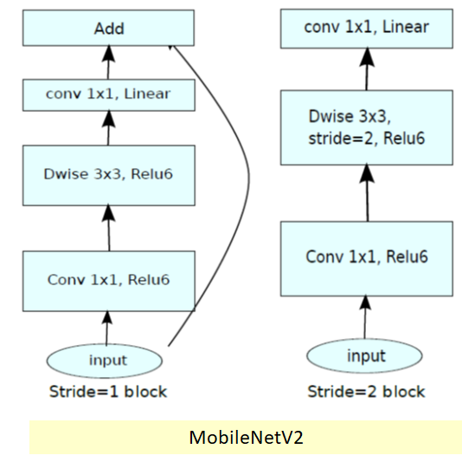

*Figure 4 Mobile Net V2 Block Diagram* (Review: MobileNetV2 — Light Weight Model (Image Classification), 2022)

Block 1:

* Input
* 1*1 Convolutional with ReLU 6
* Depthwise convolution with ReLU 6
* 1*1 Convolutional without any linerarity
* Add
* Residual connection

Block 2:

* Input
* 1*1 Convolutional with ReLU 6
* Depthwise convolution with stride = 2 and ReLU 6
* 1*1 Convolutional without any linerarity

## 3.3.4 DIFFERENT TYPES OF CONVOLUTION LAYERS –

**1] 1*1 Convolution –**

At Network-in-Network (NiN), 1x1 convolutions were first proposed. They were widely utilised in GoogleNet architecture after that. The following are the main characteristics of such layers:

* Reduce or increase the number of dimensions.
* After convolution, reapply nonlinearity.
* It's possible to classify this as "feature pooling".

They are utilised in the following way: we have a 32x32x100 picture with 100 features, and we apply 20 1x1 convolutions filters to generate images with 32x32x20 dimensions.

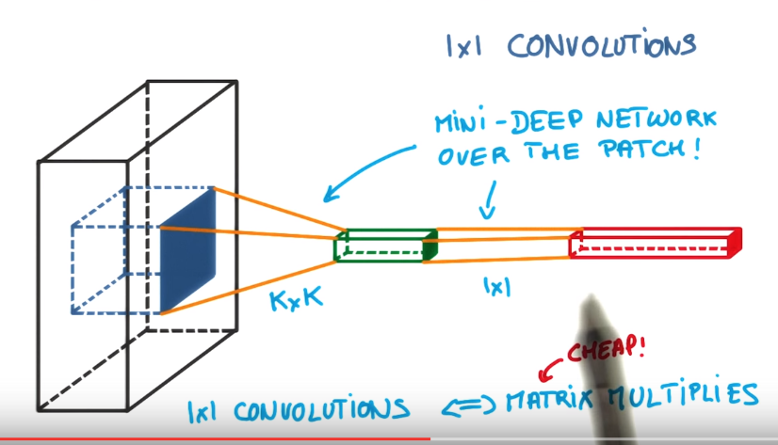

Figure 5 1*1 Convolution

**2] Spatial Separable Convolutions -**

This is the more conceptually simple of the two, and it clearly displays the notion of breaking one convolution into two. Unfortunately, due to a variety of disadvantages, spatial separable convolutions are not extensively used in deep learning (A Basic Introduction to Separable Convolutions, 2022).

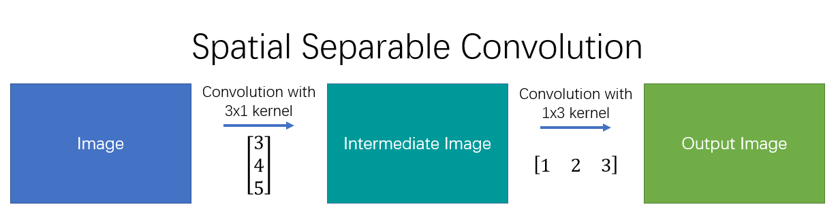

Figure 6 Spatial Separable Convolutions (A Basic Introduction to Separable Convolutions, 2022)

The spatial separable convolution derives its name from the fact that it primarily works with an image's width and height. (The other dimension, the "depth" dimension, is the number of channels in each picture.)

A spatial separable convolution divides a kernel into two smaller kernels. The most common case is to subdivide a 3x3 kernel into 3x1 and 1x3 kernels.

Instead of doing one convolution with nine multiplications, we execute two convolutions with three multiplications each to achieve the same result (6 total). The network's computational complexity lowers as the number of multiplications decreases, allowing it to run more quickly.

**3] Depth wise Separable Convolutions –**

Depthwise separable convolutions operate with kernels that can't be "factored" into two smaller kernels, unlike spatial separable convolutions. As a result, it is more widely utilised.

The depthwise separable convolution gets its name from the fact that it works with both the spatial and depth dimensions — the number of channels. Three channels are possible in an input image: RGB, CMYK, and YUV. An picture may contain numerous channels after a few convolutions. Each channel may be thought of as a different interpretation of that image; the "red" channel, for example, interprets the "redness" of each pixel, the "blue" channel interprets the "blueness" of each pixel, and the "green" channel interprets the "greenness" of each pixel. An picture with 64 channels can be interpreted in 64 distinct ways (A Basic Introduction to Separable Convolutions, 2022).

A depthwise separable convolution, like the spatial separable convolution, separates a kernel into two independent kernels that perform two convolutions: depthwise and pointwise.

**3.1] Depthwise Convolution:**

In the first part, depthwise convolution, we give the input image a convolution without changing the depth. We do so by using 3 kernels of shape 5x5x1.

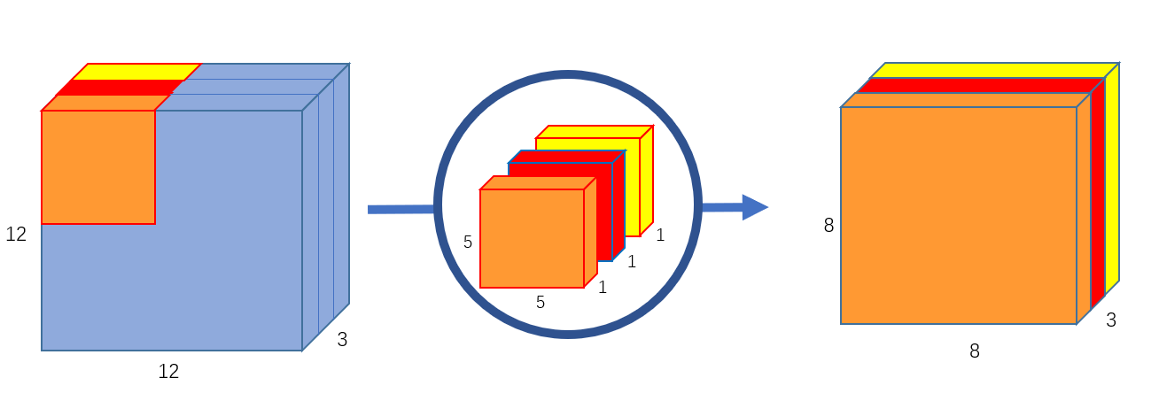

Figure 7 Depthwise Convolution (A Basic Introduction to Separable Convolutions, 2022)

Each 5x5x1 kernel iterates 1 channel of the image (note: 1 channel, not all channels), getting the scalar products of every 25 pixel group, giving out a 8x8x1 image. Stacking these images together creates a 8x8x3 image.

**3.2] Pointwise Convolution:**

A 12x12x3 picture was originally convolutioned into an 8x8x256 image. The depthwise convolution has currently converted the 12x12x3 picture into an 8x8x3 image. The number of channels in each picture must now be increased.

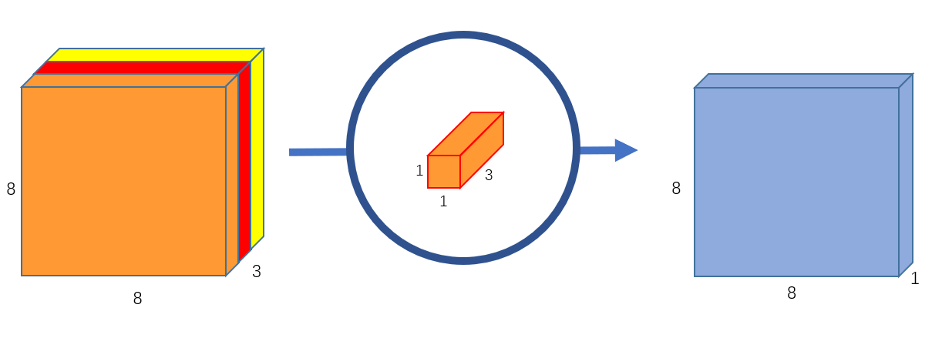

Figure 8 Pointwise Convolution (A Basic Introduction to Separable Convolutions, 2022)

The pointwise convolution gets its name from the fact that it utilises a 1x1 kernel, which iterates across every single point. This kernel has a depth equal to the number of channels in the input picture; in our example, three. To generate an 8x8x1 image, we cycle a 1x1x3 kernel across our 8x8x3 picture.

## 3.3.5 WORKING OF A MOBILENET V2 –

MobileNet V2 uses depthwise convolutions. In this architecture, the job of the convolutional layer is split between 3 layers. First is 1 * 1 Expansion convolutional layer which filters the input which is then fed to 3 * 3 Depthwise convolutional layer, which gives new features. Then these new features are fed to the final projection layer – it projects the data with the number of dimensions or channels into a tensor with a much lower number of dimensions.

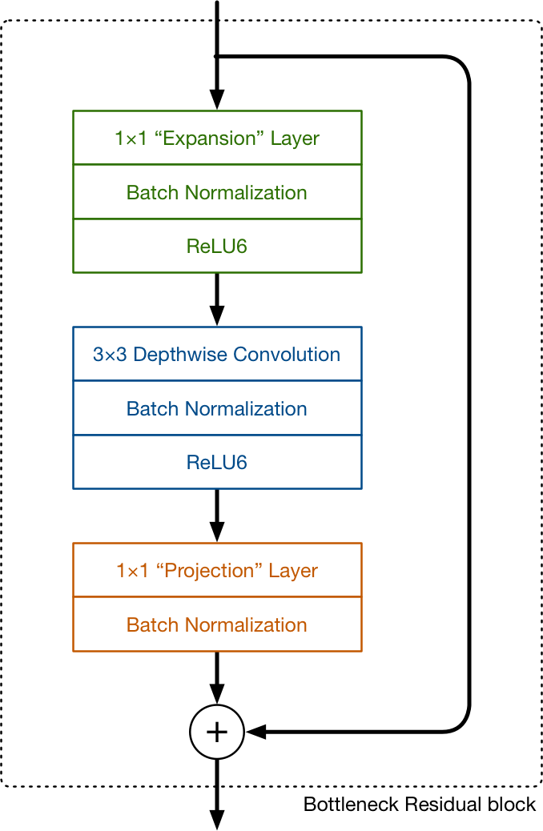

Figure 9 Main Building Bolck of MobileNet V2

For example, the depthwise layer may operate on a tensor with 144 channels, which the projection layer will subsequently reduce to 24 channels. Because it lowers the quantity of data that travels through the network, this type of layer is also known as a bottleneck layer. (This is where the term "bottleneck residual block" comes from; each block's output is a bottleneck.)

The first layer is convolutional is a 1 * 1 convolution layer. Which expands the number of channels in the data before it goes into the depthwise convolution. Hence, this expansion layer always has more output channels than input channels. It’s the opposite of the projection layer.

The expansion of data is decided by the expansion factor. The default expansion factor is 6.

If a tensor with 24 channels enters the block, the expansion layer first turns it into a new tensor with 24 * 6 = 144 channels. Following that, the depthwise convolution filter is applied to the 144-channel tensor. Finally, the projection layer reduces the 144 filtered channels to a lesser number, say 24, once again.

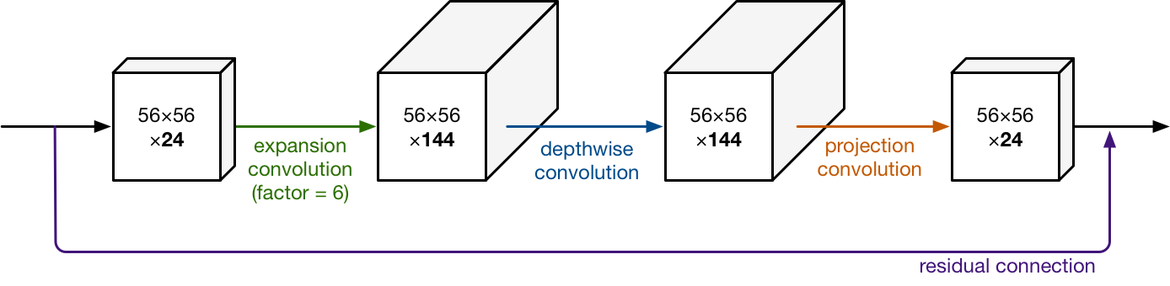

Figure 10 Example of a bottleneck residual connection

Hence input and output blocks are low-dimensional tensors, while the filtering step that happens inside the block is done on a high-dimensional tensor.

A residual connection is used as a building piece in the Mobilenet V2. This functions identically like ResNet and exists to aid in the flow of gradients across the network. (The residual connection is only utilised when the number of channels entering the block equals the number of channels exiting it, which is not always the case because the output channels are expanded every few blocks.)

Each layer has batch normalization, and the activation function is ReLU6. However, the output of the projection layer does not have an activation function applied to it.

Convolution layers are followed by batch normalisation, as is customary in current systems. MobileNet's activation function is ReLU6. This works similarly to the well-known ReLU, except it prevents activations from getting too large. When employing low-precision computing, the authors of the MobileNet study discovered that ReLU6 is more resilient than ordinary ReLU (Hollemans, 2022).

.

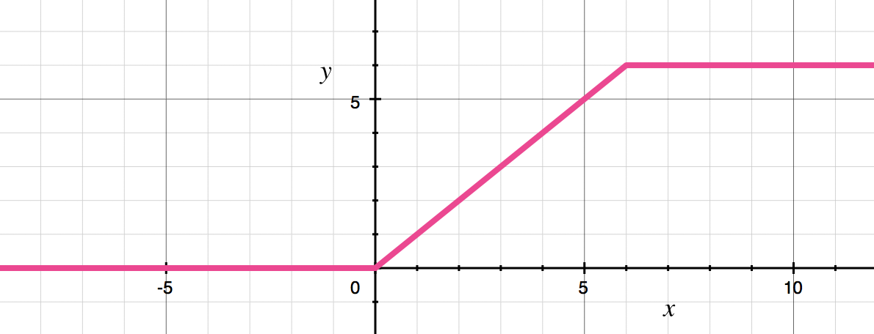

Figure 11 ReLU6 activation function

## 3.3.6 ADVANTAGES OF A MOBILENET V2 –

* MobileNets are small deep neural networks that are well-suited to mobile and embedded vision applications.
* MobileNets are built using depthwise separable convolutions and a simplified design.
* MobileNet makes use of two basic global hyperparameters to effectively balance accuracy and latency.
* Object identification, fine-grain classification, facial recognition, large-scale geo localisation, and other applications might all benefit from MobileNet.
* Network size has been reduced to 17MB.
* The number of parameters has been reduced to 4.2 million.
* They perform better and are more suitable for mobile apps.
* Convolutional neural network with a small latency.

## 3.4 OPTICAL CHARACTER RECOGNITION –

The use of technology to detect printed or handwritten text characters inside digital pictures of physical documents, such as a scanned paper document, is known as OCR (optical character recognition). OCR is a technology that examines a document's text and converts the characters into code that may be utilised for data processing. Text recognition is a term that is occasionally used to refer to OCR.

OCR systems consist of a hardware and software combination that converts physical documents into machine-readable text. Text is copied or read using hardware such as an optical scanner or dedicated circuit board, while further processing is usually handled by software. Artificial intelligence (AI) may also be used in software to achieve more complex methods of intelligent character recognition (ICR), such as detecting languages or handwriting styles.

## 3.4.1 EASYOCR –

PyTorch is the backend handler for EasyOCR, which is a Python library. EasyOCR, like any other OCR, identifies text from images, but in my experience, it is the most easy approach to detect text from photos, especially when a high-end deep learning library (PyTorch) supports it in the backend, which increases its accuracy. For detection purposes, EasyOCR supports more than 42 languages. EasyOCR was developed by a firm called Jaided AI.

# CHAPTER 4: EXPERIMENTATION & ANALYSIS

## 3.1 INTRODUCTION

The automatic dock detection and identification system recognises the vehicle's licence plate. As an input source, a photograph or a live camera feed can be used. Using the input stream, the pre-trained TensorFlow model is used to detect the presence of the picture section of the licence plate image. The licence plate is then cropped before being transmitted to EasyOCR for character recognition. EasyOCR is used to return the characters on the licence plate. The results should then be saved to a CSV file.

## To train our model, we utilised the TensorFlow Object Detection Model. The test images were found using Kaggle. EasyOCR was used to simplify OCR.The entire code will be written in Jupyter Notebook.

## 3.2 TENSORFLOW OBJECT DETECTION – MOBILENET V2

### 3.2.1 SETTING UP PATHS AND DOWNLOADING MODEL

The model training was performed on Jupyter Notebook.

Initially, we set up paths for our model in the Tensorflow folder like ‘models’, ‘scripts’, ‘workspace’, and ‘protoc’. Then we downloaded the TensorFlow model garden in the ‘models’ folder [Tensorflow - models], which installs libraries/dependencies to our virtual environment. Then we download the pre-trained model ‘ssd_mobilenet_ v2_ fpnlite_ 320x320_ coco17_ tpu-8’ [Tensorflow – workspace – pre-trained models - ssd_ mobilenet_ v2_ fpnlite_ 320x320_ coco17_tpu-8].

The dataset used for this model is “Car License Plate Detection”, which is available on Kaggle ([https: / / www.kaggle.com / andrewmvd / car-plate-detection](http://https:%20/%20/%20www.kaggle.com%20/%20andrewmvd%20/%20car-plate-detection)), and further to more images were added to that dataset as mentioned in the methods above. This dataset contains images of cars' and bikes' license plates and their bounding box annotation. In Tensorflow – workspace - images folder, we created two new folders viz., test and train. Then we manually split the data set to test and train folders. Then we put 749 images in the ‘train’ folder and 84 in the ‘test’ folder images along with their bounding box annotations. Annotation gives coordinates for the region of interest – which is an area around the license plate to be detected.

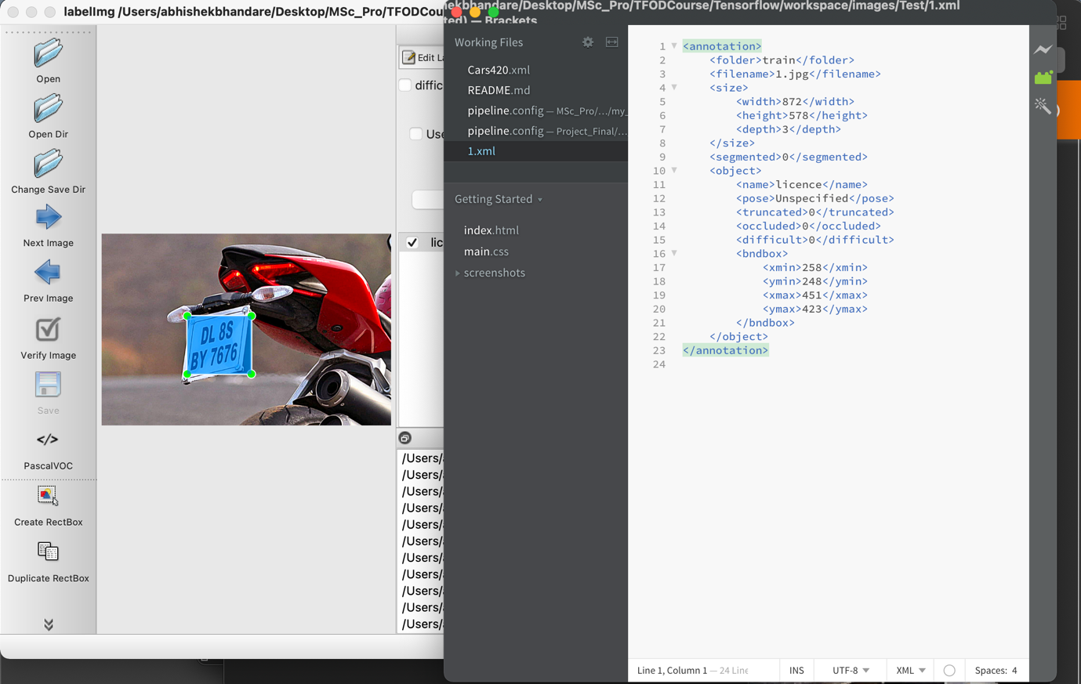

Figure 12 Annotations giving coordinates for Region of Interest

Then we created the label map with one label class called ‘licence’ (for Car License Plate). Because all the annotations of our data set contain one object as ‘licence’, which contains all coordinates for the region of interest (which is an area around the license plate to be detected) under the ‘bounding box’ tag. These bounding boxes will then be fed to train MobileNet V2 model which in return will provide detected number plates from input images.

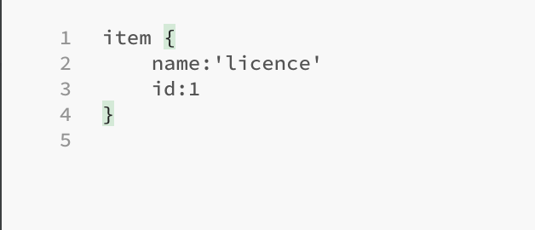

Figure 13 Lebel Map

Then, using the Tensorflow model zoo GitHub, we download the GenerateTFRecord file to build an evaluation event for MobileNet V2. We must edit the GenerateTFRecord file to access the bndbox> object from all annotations, which provides coordinates for the region of interest in the picture, because the bounding box in annotations is at the 5th key in the object tag. This is accomplished by modifying the GenerateTFRecord file's indexing.

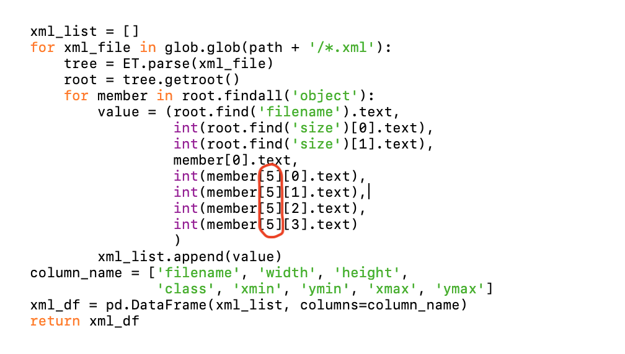

Figure 14 Updating Indexing in GenerateTFRecord

Then we download configurations for MobileNet V2 from the Tensorflow model zoo GitHub. Then we copy pipline.config file from ‘pre-trained-models’ folder [Tensorflow – workspace – pre trained models - ssd_ mobilenet_v2_ fpnlite_ 320x320_ coco17_ tpu- 8] to the ‘Training’ folder [Tensorflow – workspace – models - my_ ssd_ mobnet]. This pipline.config file has all the default configurations of MobileNet V2, which can be modified.

### 3.2.2 TRAINING MODEL

Then we train our model under 2 conditions to get maximum accuracy from our model. The conditions are as follows –

*1] Model 1:*

* 433 images feed = 20 test images + 421 train images
* Batch size = 16, epochs = 1, steps = 10,000

*2] Model 2:*

* 833 images feed = 84 test images + 749 train images
* Batch size = 32, epochs = 3, steps = 10,000

To achieve this, we made changes to batch size and number of epochs in pipline.config file and kept the rest configurations as default.

Then we train our model with the above conditions by running a training script ‘model_main_tf2.py’. When the model is successfully trained, we get all the losses viz. classification, localization, regularization, and total loss till the 10k epochs.

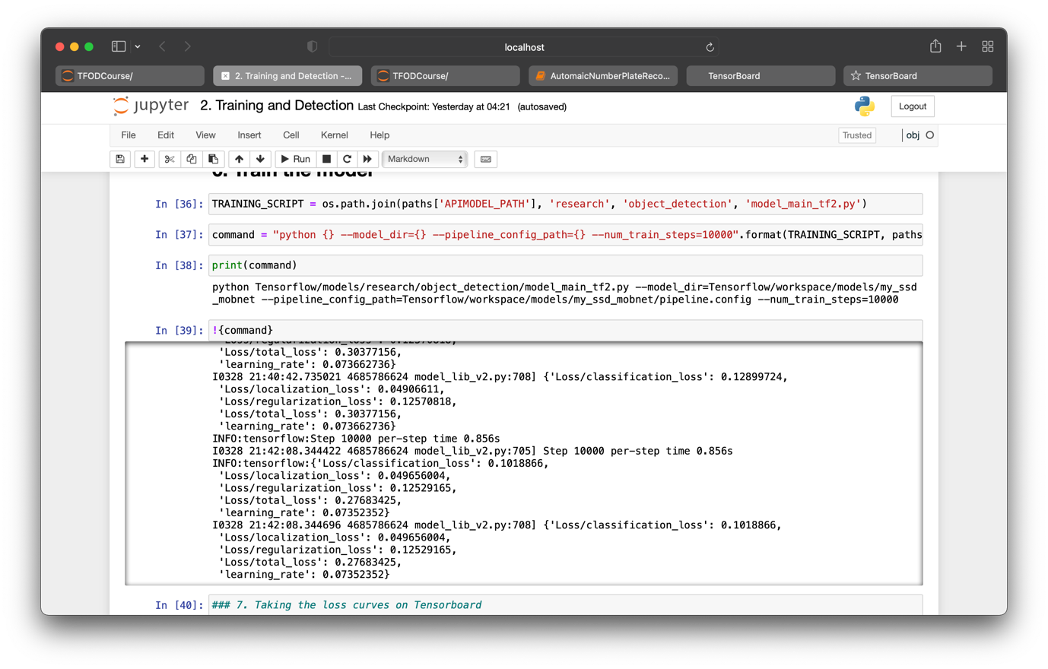

Figure 15 Training MobileNet V2 and loss results at 10,000 steps

After training our model we can detect the number plates of the vehicle from the input image. In our code, we have collected all our image detections in a variable called ‘detections’.

While running this model it can consume a lot of GPU memory, so we can set a memory limit of ‘5120’. In this way, we can allocate 5GHz of memory to TensorFlow on our CPU.

Then optical character recognition (OCR) method is applied to this region of interest to bring text data into a machine-readable format. Then detected number plate is fed to OCR through the ‘detections’ variable. The optimum result is achieved by changing the detection threshold value. The threshold value is nothing but the value over which our model is going to render results. The detection threshold value should be minimum to read text from low-quality images.

# CHAPTER 4: RESULTS

## 4.1 INTRODUCTION

In this chapter, we shall discuss the results of our implementation. The results of model training, model evaluation and final results of detection shall be shown and discussed herein.

## 4.2 EVALUATION OF THE MODEL

When the model is trained successfully, the training instances will be generated in our training folder. In our experiment, we have 11 checkpoints, which will help us to evaluate our model. We use Tensor Board to visualize our model. The model is trained under 2 conditions as follows –

*1] Model 1:*

* 433 images feed = 20 test images + 421 train images
* Batch size = 16, epochs = 1, steps = 10,000

*2] Model 2:*

* 833 images feed = 84 test images + 749 train images
* Batch size = 32, epochs = 3, steps = 10,000

### 4.2.1 EVALUATION OF MODEL 1

As can be seen in fig. 6, the total loss decreases with the number of training steps. Here, model 1 is trained in 10,000 (10k) steps, 1 epoch, and a batch size of 16. Therefore the maximum value of the x-axis is 10k. Here it can be seen that total losses are decreasing till 7k steps, but increase after that which shows that model is overfitting.

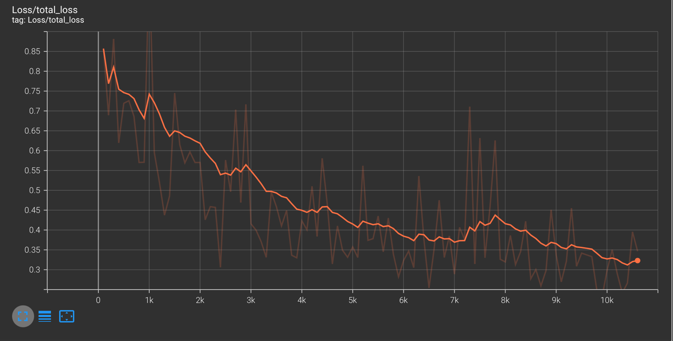

Figure 16 Total loss for model 1

**1] Classification loss:**

The classification loss is the difference between the output of the model and the actual sample data while a classification model is being trained. In figure 7, classification loss varies between 0.38 to 0.13. Initially, the loss is over 0.38 which gradually decreases down to 0.13 at the 10k step.

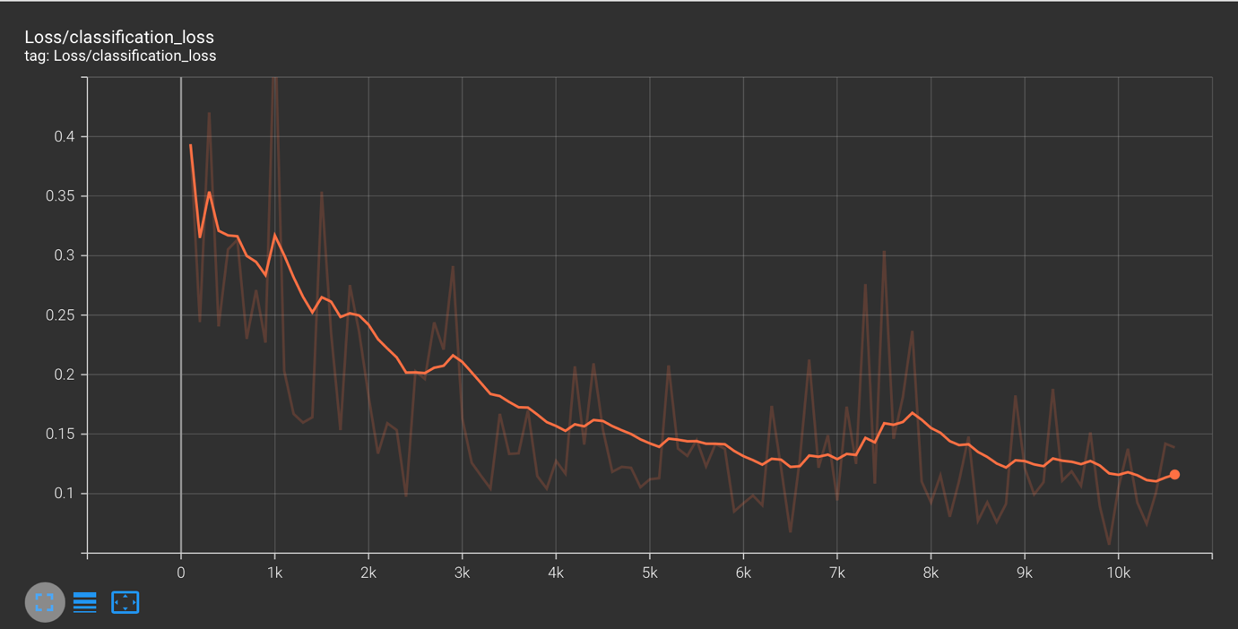

Figure 17 Classification loss of the model 1

**2] Localization loss:**

It is the loss between the predicted bounding box and the true values. Initially, the localization loss is at 0.3, which decreases to 0.08 at the 10k epochs.

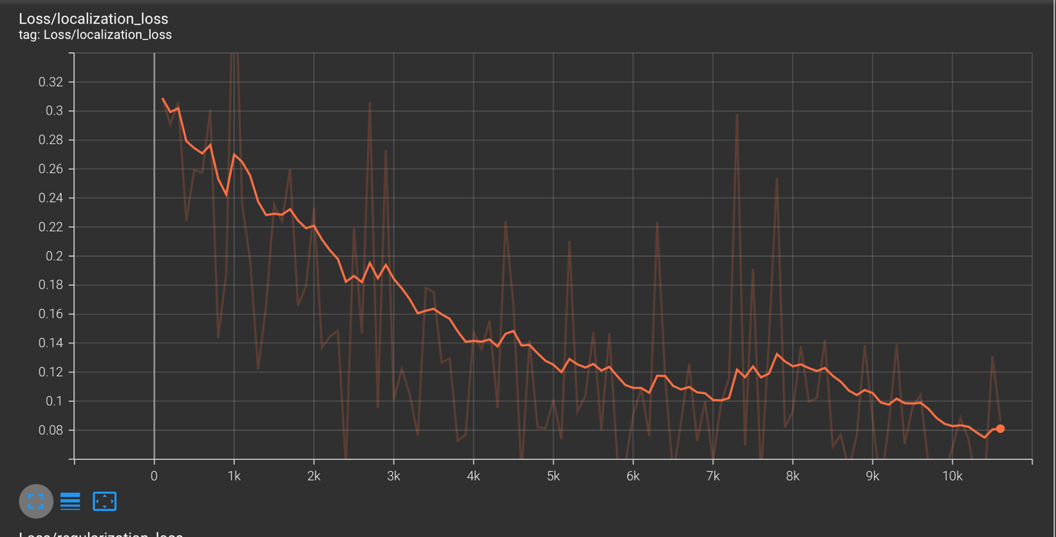

Figure 18 Localization loss of Model 1

**3] Learning rate -**

The learning rate is the hyperparameter used in the training of the neural network, generally between 0 to 1. Learning rate controls how quickly the model is adaptable to the problem. The learning reaches 0.08 at 2k steps. Then gradually decreases to 0.074 at the 10k step. 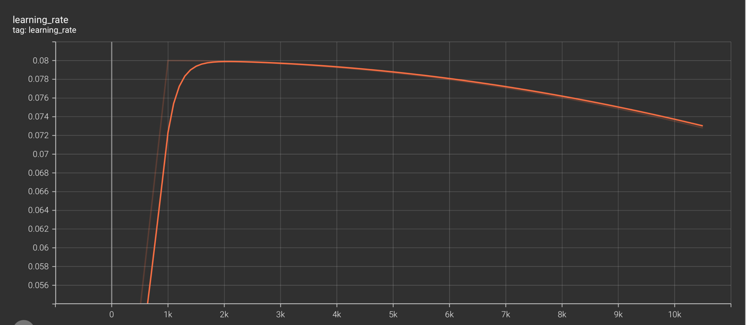

Figure 19 Learning Rate of Model 1

**4] Steps per Second -**

For example, if the batch size is 10 then for 2,000 images to be processed that will take 200 steps. The time taken by each step varies between 1.1 to 1.32 for this model. From the graph, it is clear that after 2.1k steps, steps per sec barely go above 1.26.

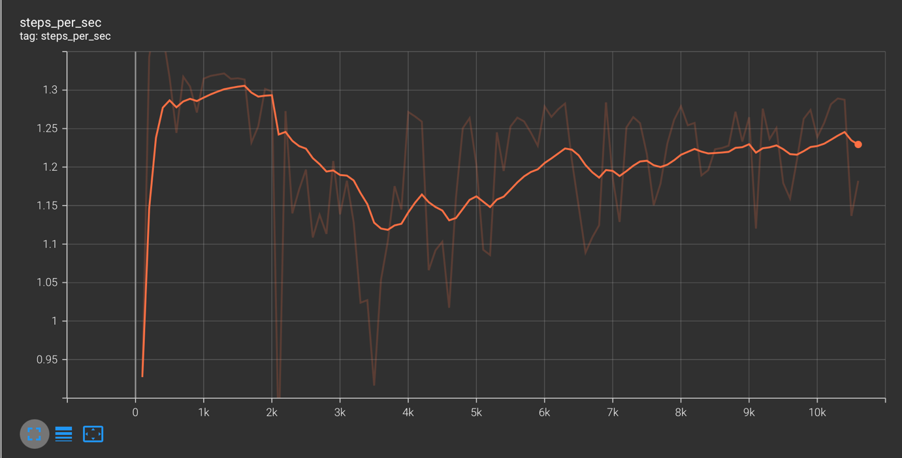

Figure 20 Steps per second of model 1

### 4.2.2 EVALUATION OF MODEL 2

In this model, the total loss decreases with the number of training steps. Here, the model has been trained in 10,000 (10k) steps, 3 epochs, and a batch size of 32. Therefore the maximum value of the x-axis is 10k. Here it can be seen that total losses are decreasing gradually and at the 10k step the total loss value is 0.34. Hence it can be seen that the model is well trained.

The evaluation matrix of model 2 is as in Fig. It shows that the model has to mean average precisions (mAP) at 0.5 and 0.75 Intersection over Union (IOU) are 0.95 and 0.73 respectively. The overall mean average precisions (mAP) at the 10,000th step is 0.6. Whereas the average recall with 100 detections is 0.68. Average Recalls with 100 detections for small (area < 32^2 pixels) and large objects (96^2 pixels < area < 10000^2 pixels) are 0.5 and 0.71 respectively.

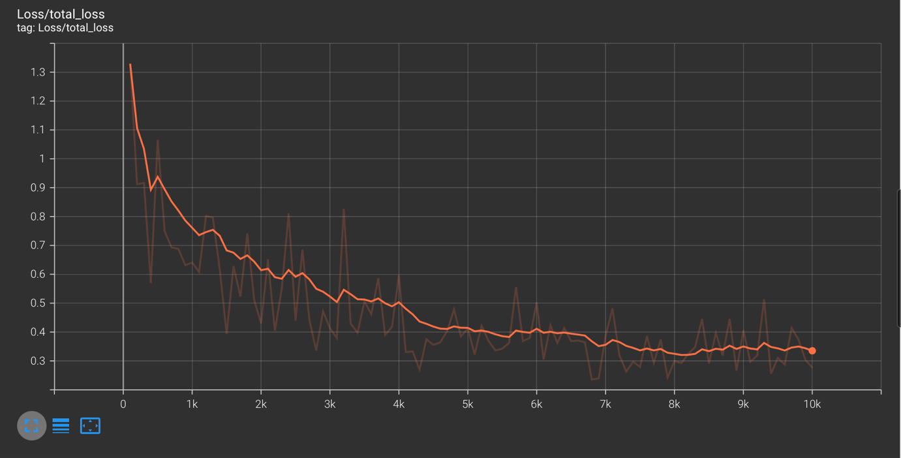

Figure 21 Total loss of model 2

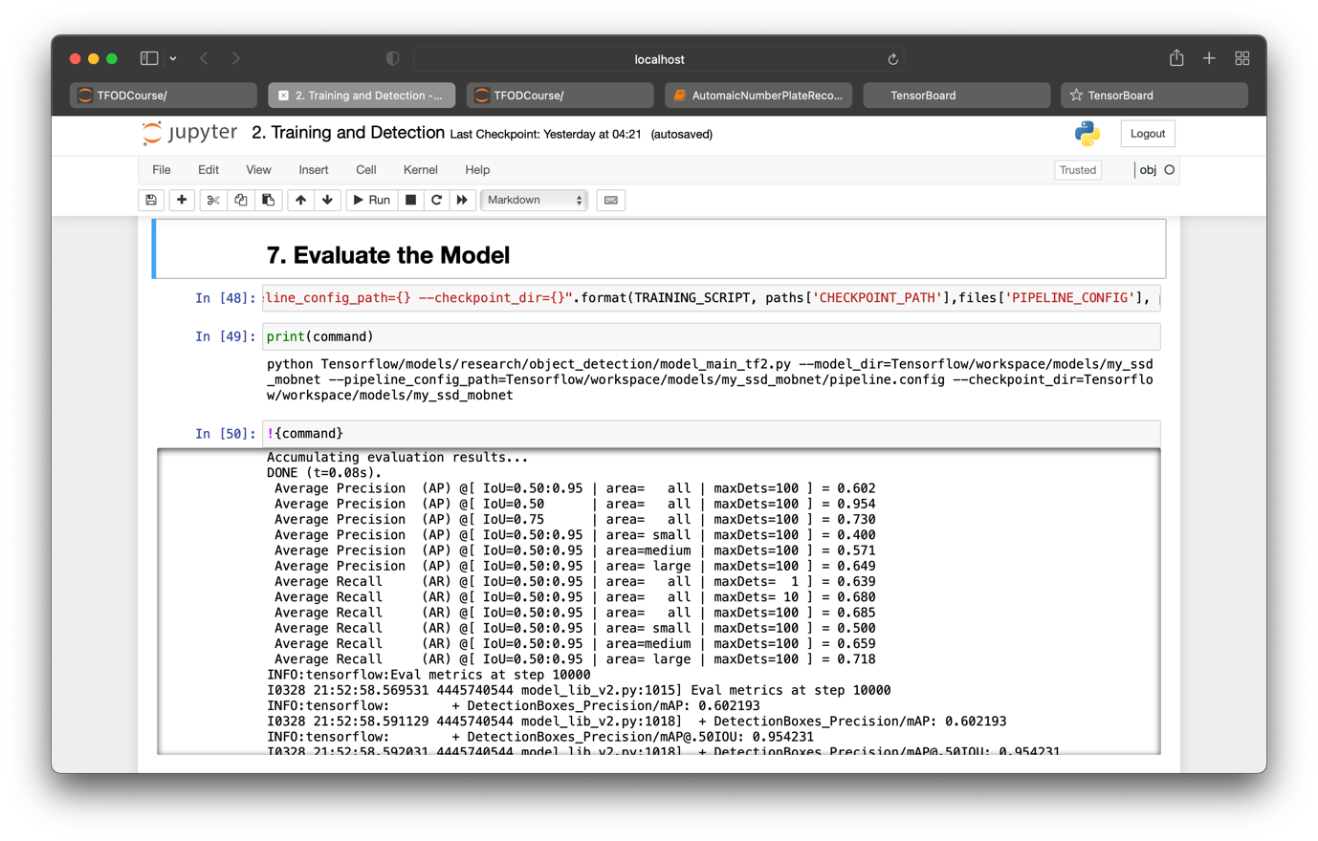

Figure 22 Evaluation Matrics of Model 2

**1] Classification loss:**

The classification loss for Model 2 varies from 0.63 to 0.12. Here we could see that classification loss drops from 0.63 to 0.3 within the first 1k steps only, which can confirm that the model is being trained properly. This also shows a good sign towards the learning rate of the model. The classification loss at 10k steps is 0.12.

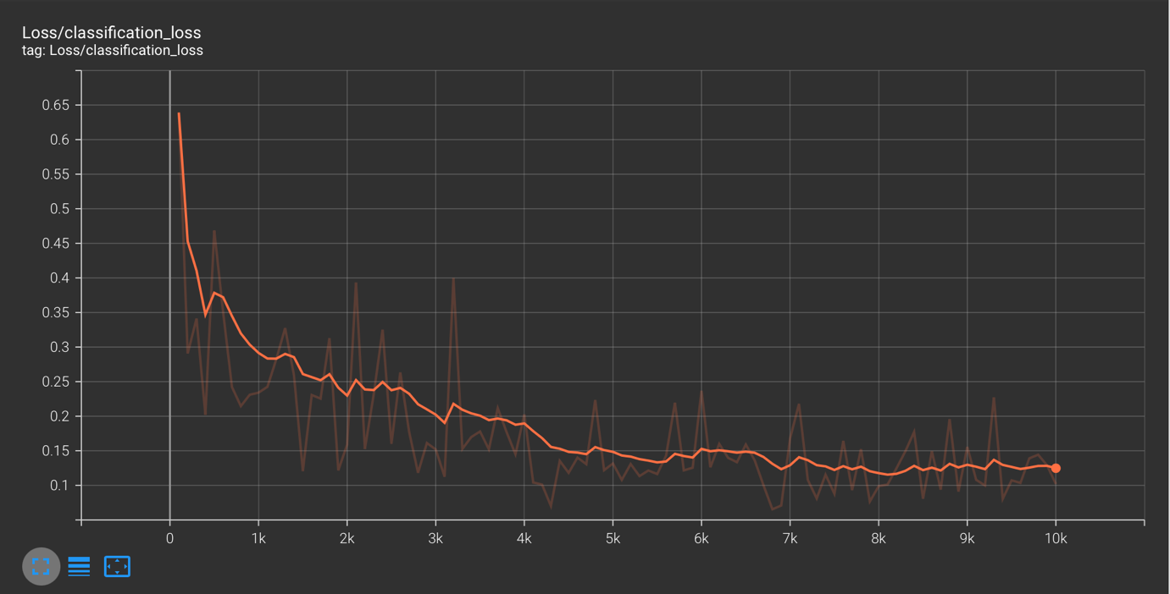

Figure 23 Classification loss of Model 2

**2] Localization loss –**

The classification loss for Model 2 varies between 0.53 to 0.08 The localization loss at 10k steps is 0.08.

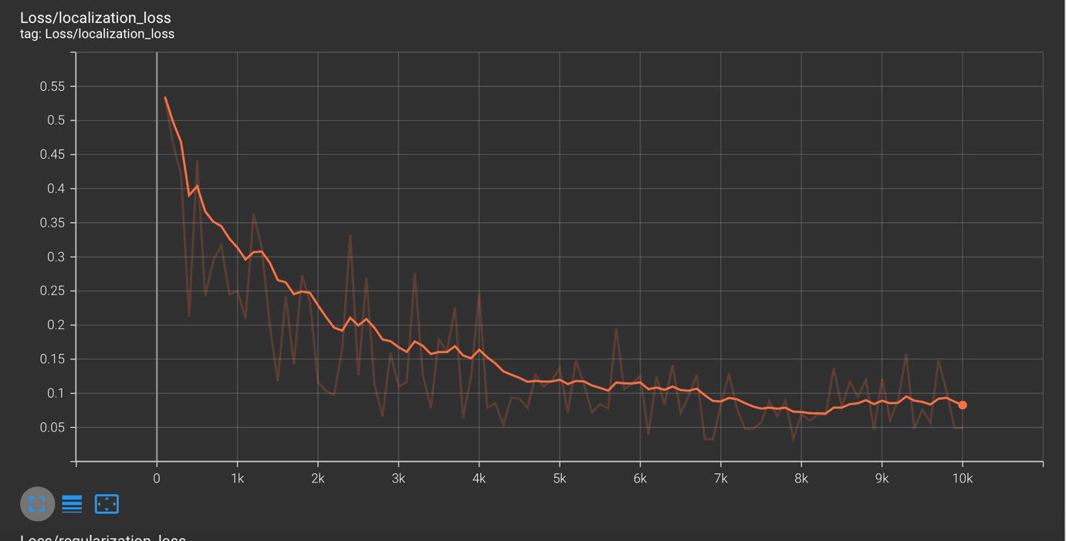

Figure 24 Localization loss of Model 2

**3] Learning rate –**

The learning rate varies between 0 to 1. The learning rate reaches 0.08 in 1.5 k steps. Whereas Model 1 took 2k steps to reach 0.08.

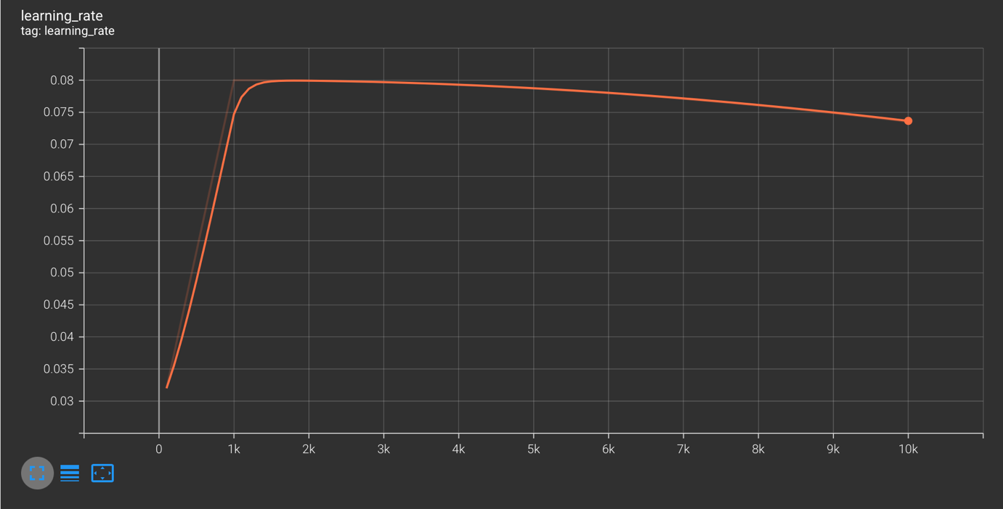

Figure 25 Learning rate of Model 2

**4] Steps each second –**

The time taken by each step varies between 1.1 to 1.27 for this model. From the graph, it’s clear that after 2.1k steps, steps per sec barely go above 1.22.

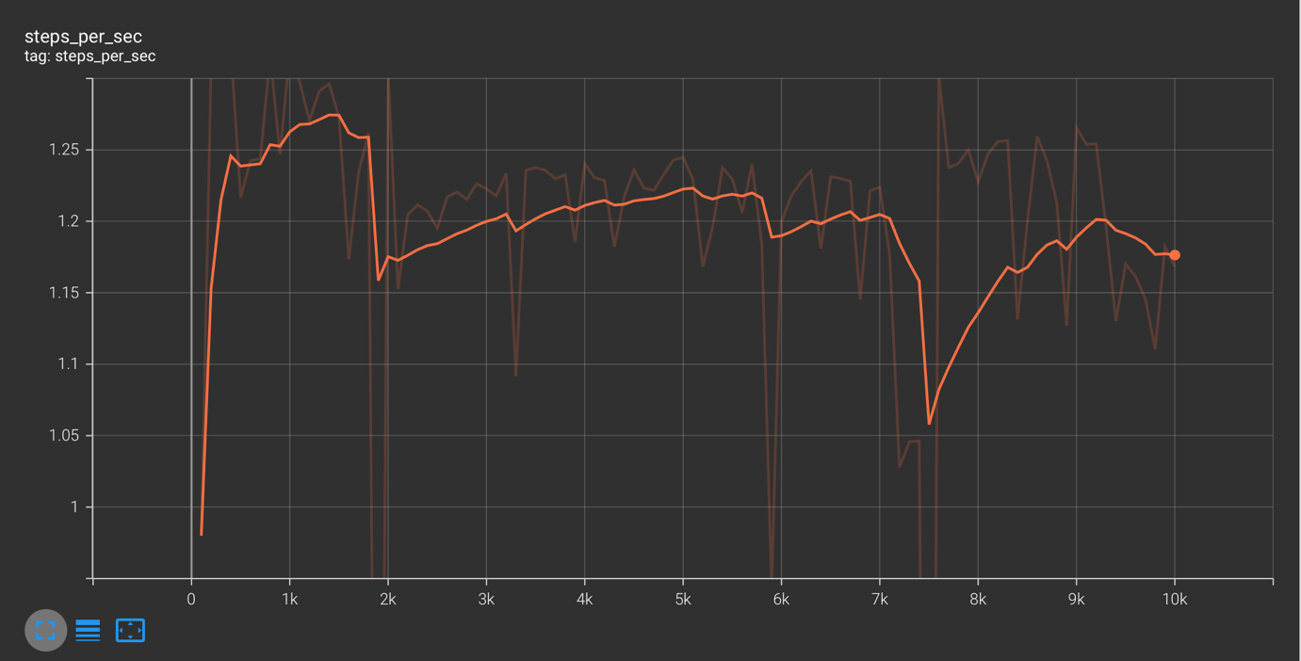

Figure 26 Steps per second of Model 2

The key technical features of both the models are tabled as below –

|  |  |  |  |  |
| --- | --- | --- | --- | --- |
| **Parameters** | **Values - Model 1** | | **Values - Model 2** | |
|  | **Training Data** | | | |
| **Losses** | **100 steps** | **10k steps** | **100 steps** | **10k steps** |
| Classification | 0.39 | 0.11 | 0.63 | 0.12 |
| Localization | 0.3 | 0.08 | 0.53 | 0.08 |
| Regularization | 0.15 | 0.12 | 0.15 | 0.12 |
| Total Loss | 0.85 | 0.32 | 1.32 | 0.34 |
| **Learning rate** | **2k step** | **10k step** | **1.5k step** | **10k step** |
|  | 0.079 (max) | 0.073 | 0.079 (max) | 0.072 |
|  | **Evaluation Data** | | | |
| Mean Average Precision (mAP) at 10k step | 0.48 | | 0.6 | |
| mAP at 0.50 IOU | 0.89 | | 0.95 | |
| mAP at 0.75 IOU | 0.42 | | 0.72 | |
| Detection Box Recall at 100 detections | 0.59 | | 0.68 | |
| small object [area < 32^2 pixels] at 100 detections | 0.55 | | 0.5 | |
| Large object [96^2 pixels < area < 10000^2 pixels] at 100 detections | 0.6 | | 0.71 | |
| **Losses at 10k step** |  | |  | |
| Classification | 0.33 | | 0.21 | |
| Localization | 0.17 | | 0.1 | |
| Regularization | 0.12 | | 0.12 | |
| Total Loss | 0.62 | | 0.44 | |

Table 2 The key technical features of both the models

In the table above, we can observe that the learning rate in model 2 has grown significantly. It took 1.5k epochs for Model 2 to attain its maximum learning rate. Model 2 has a substantially higher mean average precision than model 1. As can be seen, the precision at 0.75 IOU is 0.72, which is significantly greater than the 0.42 precision in Model 1. At the 10k step, the losses – classification, localization, and total losses – are also significantly decreased.

## 4.3 OCR TEST RESULTS

In Fig. 10, the image on the right is the image with marked annotation. There is a test image on the left, and the model has detected that license plate with 75% of accuracy. This is evaluated with Tensorboard. The accuracy of the model is calculated on basis of how close is predicted bounding box is to the actual bounding box in an image.

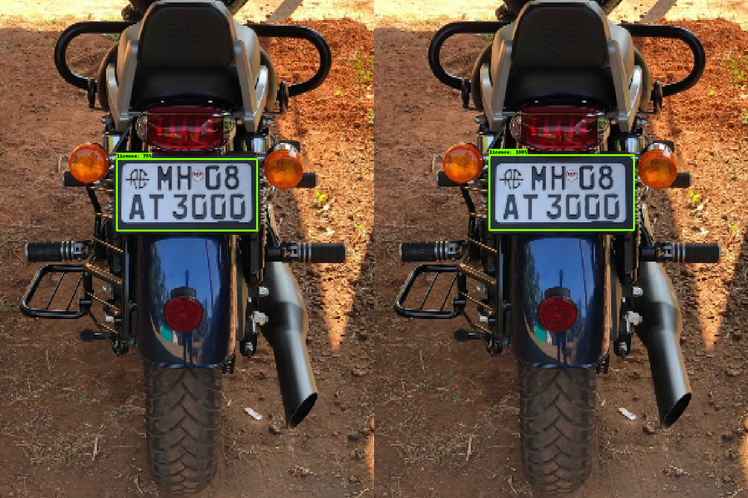

Figure 27 Training Results Model 2: Accuracy: 75%

For the use of OCR, the image of this license plate would be cropped out. The cropped image would be processed before the recognition process begins. In this, the image would be resized, smoothened, removed from the noise, segmented, edge smoothened, etc. We have applied to filter to the detected number plate. The language is set to English as all the number plates contain English Alphabet. The render method in the Easy OCR application would be used. In this case, we adjusted our detection threshold value between 0 to 1 manually. The detection threshold is the limit over which our model will render the results. If we set the value of the detection threshold to 0.5, then all the detection scores over the 0.5 value will render the results. In this example, we set the detection threshold value to 0.5, so that we can get results from low-quality images as well.

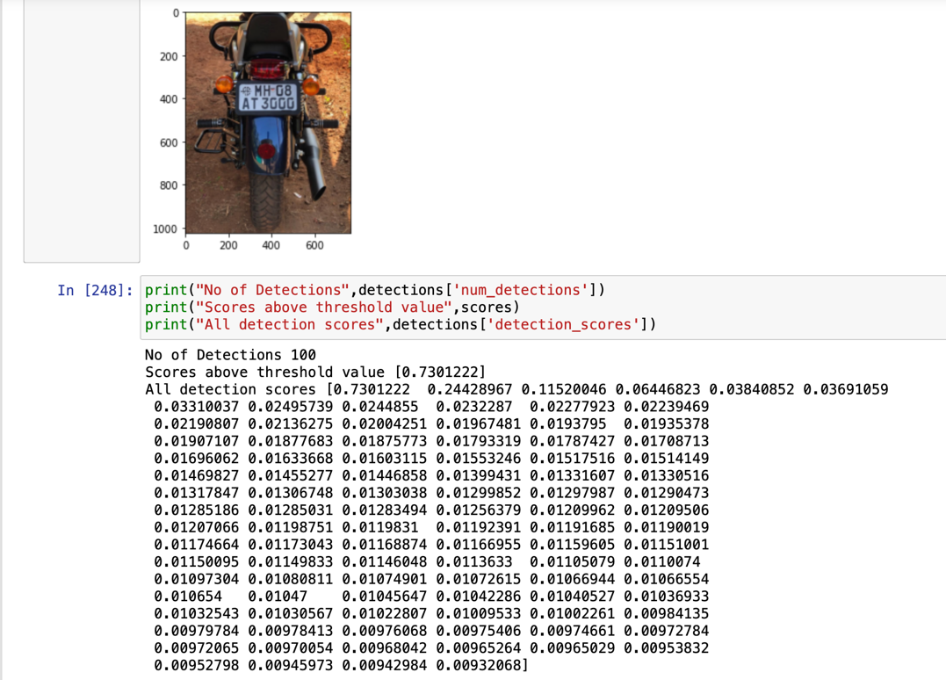

Figure 28 OCR detections of detected image 1

Then we gather OCR results, which can show accuracy for character recognition from images. Here we can see that 0.73 and 0.67 is the accuracy for the possible recognitions.

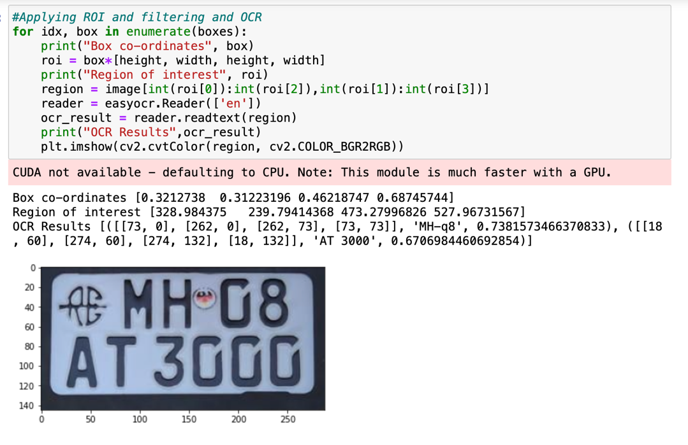

Figure 29 OCR All Results

Then we apply region threshold to filter out avoid unnecessary character recognition from input image. And we achieve our final ocr result.

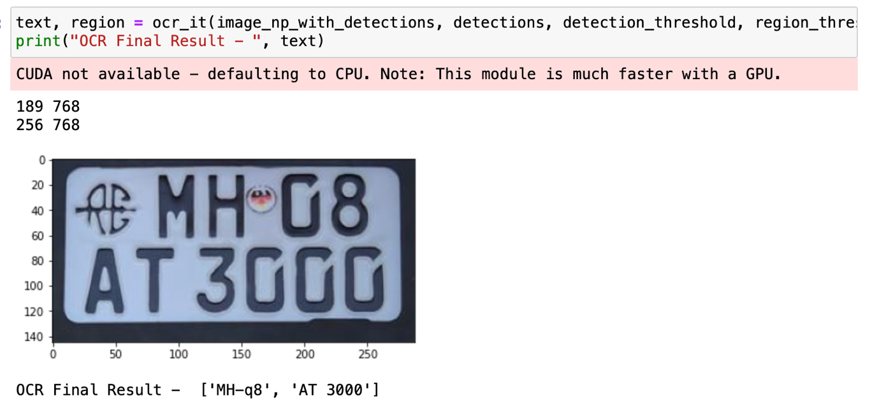

Figure 30 OCR result after detection and region threshold

Fig. 31 shows a re-test with a more complex image. Again the training image would be tested using the model we trained. In this case we have 95% of accuracy for the detection of number plate.

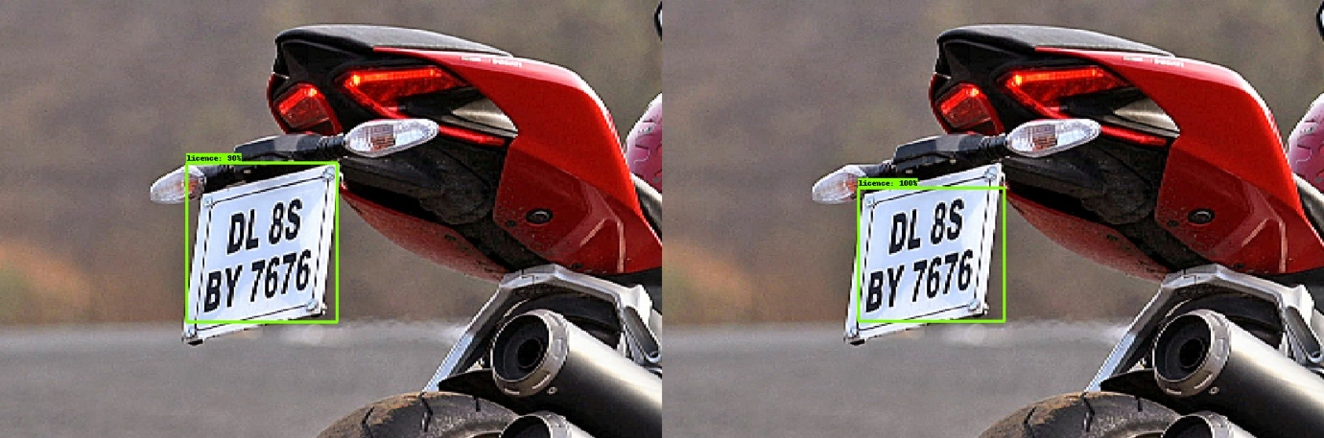

Figure 31 Evaluation result of Image 2 - 90% accuracy

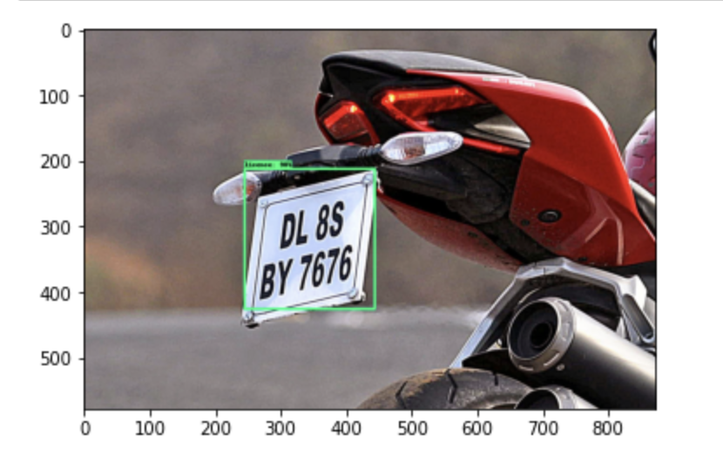

Figure 32 Detected image

## 4.4 Real Time Detections with webcam –

With OpenCV video capture functions, we can successfully detect images in real time. Again detections will stored in ‘detections’ variable. 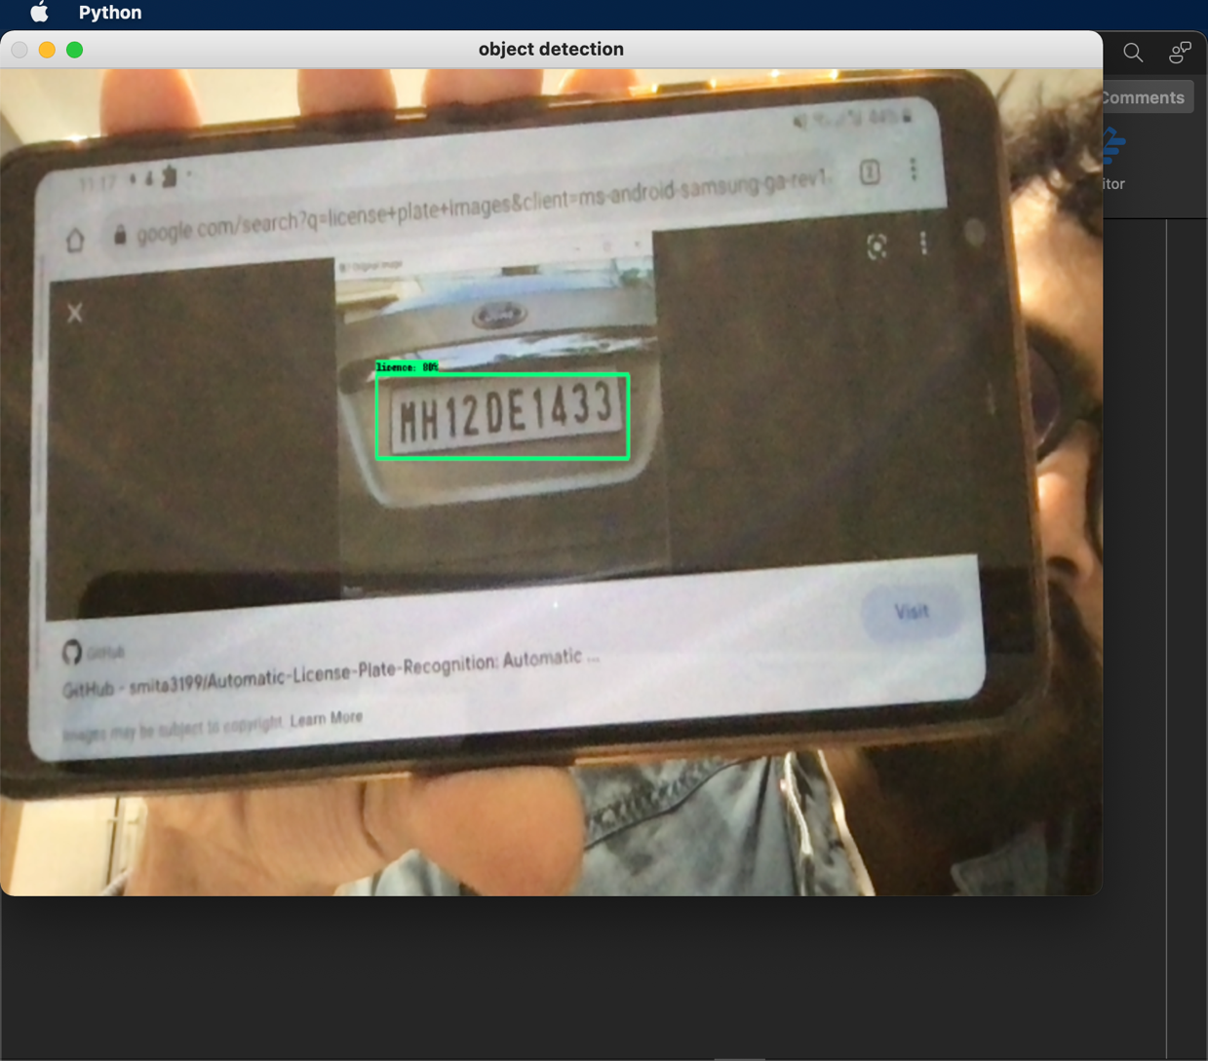

Figure 33 Real Time Detection with 80% Accuracy

# CHAPTER 5: CONCLUSION & FUTURE SCOPE

## 5.1 FUTURE SCOPE

Every project has a limitation and a possibility of a future research and improvement. Our project could have the following future scopes:

* Classifying the detected number plate into various categories as specified by the government, for example, commercial vehicle, green vehicle, electric vehicle etc.
* Classifying the vehicle’s state and country.
* *Using OCR with drone to get immense mobility*.

## 5.2 CONCLUSION

We have successfully implemented an automatic license plate recognition system. Our system can detect the number plates from a set of input images. We have also implemented the detection of the license plate from live camera feeds. The text on the license plates is recognized easily. The accuracy of 0.75 IOU is 72%, 0.75 IOU is 95% which is very good. The detected number plate characters are stored in the form of a database, in our case, a .csv file. The model used in our implementation has been trained with 749 images, Batch size = 32, epochs = 3 and in 10000 steps. The efficiency of the model could be increased by increasing the number of images and making changes to batch size and number of epochs.

# REFERENCES

Abhishek Bhandare, 2021 September. Automatic Number Plate Recognition System. University of Hertfordshire.

Duan, T.D., Du, T.H., Phuoc, T.V. and Hoang, N.V., 2005, February. Building an automatic vehicle license plate recognition system. In Proc. Int. Conf. Comput. Sci. RIVF (Vol. 1, pp. 59-63).

Agbemenu, A. S., Yankey, J., & Addo, E. O. (2018). An automatic number plate recognition system using opencv and tesseract ocr engine. *International Journal of Computer Applications, 180*(43), 1-5.

Akhtar, Z., & Ali, R. (2020). Automatic number plate recognition using random forest classifier. *SN Computer Science, 1*(3), 1-9.

Asthana, S., Sharma, N., & Singh, R. (2011). Vehicle number plate recognition using multiple layer back propagation neural networks. *International Journal of Computer Technology and Electronics Engineering (IJCTEE), 1*(1).

Babu, R. N., Sowmya, V., & Soman, K. P. (2019). Indian Car Number Plate Recognition using Deep Learning. *2019 2nd International Conference on Intelligent Computing, Instrumentation and Control Technologies (ICICICT)* (pp. 1269-1272). Kannur, India: IEEE.

Badr, A., Abdelwahab, M. M., Thabet, A. M., & Abdelsadek, A. M. (2011). Automatic number plate recognition system. *Annals of the University of Craiova-Mathematics and Computer Science Series, 38*(1), 62-71.

Balamurugan, G., Punniakodi, S., Rajeswari, K., & Arulalan, V. (2015). Automatic number plate recognition system using super-resolution technique. *2015 International Conference on Computing and Communications Technologies (ICCCT)* (pp. 273-277). Chennai, India: IEEE.

Beibut, A., Magzhan, K., & Chingiz, K. (2014). Effective algorithms and methods for automatic number plate recognition. *2014 IEEE 8th International Conference on Application of Information and Communication Technologies (AICT)* (pp. 1-4). Astana, Kazakhstan: IEEE.

Chakraborty, S., & Parekh, R. (2015). An improved template matching algorithm for car license plate recognition. *International Journal of Computer Applications, 118*(25).

Fajas, F., Yousuf, F., Remya, P. R., Pavanan, A. P., Ambadiyil, S., & Swaminathan, V. (2012). Automatic Number Plate Recognition for indian standard number plates. *2012 IV International Congress on Ultra Modern Telecommunications and Control Systems* (pp. 1026-1028). St. Petersburg, Russia: IEEE.

Fakhar, S. A., Saad, H. M., Fauzan, K. A., Affendi, H. R., & Aidil, A. M. (2019). Development of portable automatic number plate recognition (ANPR) system on Raspberry Pi. *International Journal of Electrical and Computer Engineering; Yogyakarta, 9*(3), 1805-1813.

Farhat, A., Hommos, O., Al-Zawqari, A., Al-Qahtani, A., Bensaali, F., Amira, A., & Zhai, X. (2018). Optical character recognition on heterogeneous SoC for HD automatic number plate recognition system. *EURASIP Journal on Image and Video Processing, 2018*(1), 1-17.

Gunawan, T. S., Mutholib, A., & Kartiwi, M. (2017). Performance Evaluation of Automatic Number Plate Recognition on Android Smartphone Platform. *International Journal of Electrical & Computer Engineering, 7*(4), 2088-2908.

Hadavi, S., Rai, H. B., Verlinde, S., Huang, H., Macharis, C., & Guns, T. (2020). Analyzing passenger and freight vehicle movements from automatic-Number plate recognition camera data. *European Transport Research Review, 12*, 1-17.

Kaur, E. K., & Banga, V. K. (2013). Number plate recognition using OCR technique. *International Journal of Research in Engineering and Technology, 2*(9), 286-290.

Kaur, H. (2019, November 28). *ANPR vs. RFID: Which is better?* Retrieved from Park Wheels: https://parkwheels.co.in/anpr-vs-rfid-which-is-better/

Kaur, S., & Kaur, S. (2014). An Efficient Approach for Automatic Number Plate Recognition System under Image Processing. *International Journal of Advanced Research in Computer Science, 5*(6).

Keong, W. W., & Iranmanesh, V. (2016). Malaysian automatic number plate recognition system using Pearson correlation. *2016 IEEE Symposium on Computer Applications & Industrial Electronics (ISCAIE)* (pp. 40-45). Penang, Malaysia: IEEE.

Khan, M. A., Sharif, M., Javed, M. Y., Akram, T., Yasmin, M., & Saba, T. (2018). License number plate recognition system using entropy-based features selection approach with SVM. *IET Image Processing, 12*(2), 200-209.

Khaparde, D., Detroja, H., Shah, J., Dikey, R., & Thakare, B. (2018). Survey on Automatic Number Plate Recognition System. *Int. J. Comput. Appl, 69*, 28-32.

Kulkarni, Y., Bodkhe, S., Kamthe, A., & Patil, A. (2018). Automatic number plate recognition for motorcyclists riding without helmet. *2018 International Conference on Current Trends towards Converging Technologies (ICCTCT)* (pp. 1-6). Coimbatore, India: IEEE.

Kumar, T., Gupta, S., & Kushwaha, D. S. (2016). An efficient approach for automatic number plate recognition for low resolution images. *Proceedings of the Fifth International Conference on Network, Communication and Computing* (pp. 53-57). Kyoto, Japan: ACM Digital Library.

Li, J., Van Zuylen, H., Deng, Y., & Zhou, Y. (2020). Urban travel time data cleaning and analysis for Automatic Number Plate Recognition. *Transportation Research Procedia, 47*, 712-719.

Liu, J., Zheng, F., van Zuylen, H. J., & Li, J. (2020). A dynamic OD prediction approach for urban networks based on automatic number plate recognition data. *Transportation Research Procedia, 47*, 601-608.

Mateen, A., Anwar, M. A., Afsar, S., Nawaz, Q., Yasin, Q., Odinaev, R., & Shahid, M. A. (2021). Performance Analysis on Automatic Number Plate Recognition System and Methods. *International Journal of Advanced Trends in Computer Science and Engineering, 10*(2), 1289-1295.

Mirzahossein, H., Gholampour, I., Sedghi, M., & Zhu, L. (2021). How realistic is static traffic assignment? Analyzing automatic number-plate recognition data and image processing of real-time traffic maps for investigation. *Transportation Research Interdisciplinary Perspectives, 9*, 100320.

Mondal, M., Mondal, P., Saha, N., & Chattopadhyay, P. (2017). Automatic number plate recognition using CNN based self synthesized feature learning. *2017 IEEE Calcutta Conference (CALCON)* (pp. 378-381). Kolkata, India: IEEE.

Mufti, N., & Shah, S. A. (2021). Automatic number plate Recognition: A detailed survey of relevant algorithms. *Sensors, 21*(9), 3028.

Mutholib, A., Gunawan, T. S., & Kartiwi, M. (2012). Design and implementation of automatic number plate recognition on android platform. *2012 International Conference on Computer and Communication Engineering (ICCCE)* (pp. 540-543). Kuala Lumpur, Malaysia: IEEE.

Ozbaran, Y., & Tasgin, S. (2019). Using cameras of automatic number plate recognition system for seat belt enforcement a case study of Sanliurfa (Turkey). *Policing: An International Journal*.

Patel, C., Shah, D., & Patel, A. (2013). Automatic number plate recognition system (anpr): A survey. *International Journal of Computer Applications, 69*(9).

Patil, P., Kanagasabapathi, C., & Yellampalli, S. S. (2017). Automatic number plate recognition system for vehicle identification. *2017 International Conference on Electrical, Electronics, Communication, Computer, and Optimization Techniques (ICEECCOT)* (pp. 431-434). Mysuru, India: IEEE.

Plate Recogniser. (2021). *ANPR for India*. Retrieved from Plate Recogniser: https://platerecognizer.com/anpr-for-india/

Prema, K. (2021). Automatic Number Plate Recognition Using Deep Learning. *urkish Journal of Computer and Mathematics Education (TURCOMAT), 12*(9), 265-267.

Puranic, A., Deepak, K. T., & Umadevi, V. (2016). Vehicle number plate recognition system: a literature review and implementation using template matching. *International Journal of Computer Applications, 134*(1), 12-16.

Rhead, M., Gurney, R., Ramalingam, S., & Cohen, N. (2012). Accuracy of automatic number plate recognition (ANPR) and real world UK number plate problems. *2012 IEEE international carnahan conference on security technology (ICCST)* (pp. 286-291). Newton, MA, USA: IEEE.

Rosebrock, A. (2020, September 21). *OpenCV: Automatic License/Number Plate Recognition (ANPR) with Python*. Retrieved from PyImageSearch: https://www.pyimagesearch.com/2020/09/21/opencv-automatic-license-number-plate-recognition-anpr-with-python/

Sanjana, S., Shriya, V. R., Vaishnavi, G., & Ashwini, K. (2021). A review on various methodologies used for vehicle classification, helmet detection and number plate recognition. *Evolutionary Intelligence, 14*(2), 979-987.

Selokar, A. R., & Jain, S. (2014). Automatic number plate recognition system using a fast stroke-based method. *IEEE, TRANSACTIONS ON MULTIMEDIA, 1*(7), 1-5.

Sferle, R. M., & Moisi, E. V. (2019). Automatic Number Plate Recognition for a Smart Service Auto. *2019 15th International Conference on Engineering of Modern Electric Systems (EMES)* (pp. 57-60). Oradea, Romania: IEEE.

Shaikh, S., Lahiri, B., Bhatt, G., & Raja, N. (2013). A novel approach for automatic number plate recognition. *2013 International Conference on Intelligent Systems and Signal Processing (ISSP)* (pp. 375-380). Vallabh Vidyanagar, India: IEEE.

Shidore, M. M., & Narote, S. P. (2011). Number plate recognition for indian vehicles. *IJCSNS International Journal of Computer Science and Network Security, 11*(2), 143-146.

Shreyas, R., Kumar, B. P., Adithya, H. B., Padmaja, B., & Sunil, M. P. (2017). Dynamic traffic rule violation monitoring system using automatic number plate recognition with SMS feedback. *2017 2nd International Conference on Telecommunication and Networks (TEL-NET)* (pp. 1-5). Noida, India: IEEE.

Sinha, H., Soumya, G. V., Undavalli, S., & Jeyanthi, R. (2021). An Effective Real-Time Approach to Automatic Number Plate Recognition (ANPR) Using YOLOv3 and OCR. *Intelligent Systems, Technologies and Applications* (pp. 299-314). Singapore: Springer.

Suvon, M. N., Khan, R., & Ferdous, M. (2020). Real Time Bangla Number Plate Recognition using Computer Vision and Convolutional Neural Network. *2020 IEEE 2nd International Conference on Artificial Intelligence in Engineering and Technology (IICAIET)* (pp. 1-6). Kota Kinabalu, Malaysia: IEEE.

Yousef, K. M., Al-Tabanjah, M., Hudaib, E., & Ikrai, M. (2015). SIFT based automatic number plate recognition. *2015 6th International Conference on Information and Communication Systems (ICICS)* (pp. 124-129). Amman, Jordan: IEEE.

Sinha, S., 2022. *Why Google’s MobileNetV2 Is A Revolutionary Next Gen On-Device Computer Vision Network*. [online] Analytics India Magazine. Available at: <https://analyticsindiamag.com/why-googles-mobilenetv2-is-a-revolutionary-next-gen-on-device-computer-vision-network/?cv=1> [Accessed 8 April 2022].

Medium. 2022. *Review: MobileNetV2 — Light Weight Model (Image Classification)*. [online] Available at: <https://towardsdatascience.com/review-mobilenetv2-light-weight-model-image-classification-8febb490e61c> [Accessed 8 April 2022].

Hollemans, M., 2022. *MobileNet version 2*. [online] Machinethink.net. Available at: <https://machinethink.net/blog/mobilenet-v2/> [Accessed 21 April 2022].

# 

# APPENDIX:

**1] Training and Detection**

***0. Setting up Paths***

import os

CUSTOM_MODEL_NAME = 'my_ssd_mobnet'

PRETRAINED_MODEL_NAME = 'ssd_mobilenet_v2_fpnlite_320x320_coco17_tpu-8'

PRETRAINED_MODEL_URL = 'http://download.tensorflow.org/models/object_detection/tf2/20200711/ssd_mobilenet_v2_fpnlite_320x320_coco17_tpu-8.tar.gz'

TF_RECORD_SCRIPT_NAME = 'generate_tfrecord.py'

LABEL_MAP_NAME = 'label_map.pbtxt'

paths = {

'WORKSPACE_PATH': os.path.join('Tensorflow', 'workspace'),

'SCRIPTS_PATH': os.path.join('Tensorflow','scripts'),

'APIMODEL_PATH': os.path.join('Tensorflow','models'),

'ANNOTATION_PATH': os.path.join('Tensorflow', 'workspace','annotations'),

'IMAGE_PATH': os.path.join('Tensorflow', 'workspace','images'),

'MODEL_PATH': os.path.join('Tensorflow', 'workspace','models'),

'PRETRAINED_MODEL_PATH': os.path.join('Tensorflow', 'workspace','pre-trained-models'),

'CHECKPOINT_PATH': os.path.join('Tensorflow', 'workspace','models',CUSTOM_MODEL_NAME),

'OUTPUT_PATH': os.path.join('Tensorflow', 'workspace','models',CUSTOM_MODEL_NAME, 'export'),

'TFJS_PATH':os.path.join('Tensorflow', 'workspace','models',CUSTOM_MODEL_NAME, 'tfjsexport'),

'TFLITE_PATH':os.path.join('Tensorflow', 'workspace','models',CUSTOM_MODEL_NAME, 'tfliteexport'),

'PROTOC_PATH':os.path.join('Tensorflow','protoc')

}

files = {

'PIPELINE_CONFIG':os.path.join('Tensorflow', 'workspace','models', CUSTOM_MODEL_NAME, 'pipeline.config'),

'TF_RECORD_SCRIPT': os.path.join(paths['SCRIPTS_PATH'], TF_RECORD_SCRIPT_NAME),

'LABELMAP': os.path.join(paths['ANNOTATION_PATH'], LABEL_MAP_NAME)

}

for path in paths.values():

if not os.path.exists(path):

if os.name == 'posix':

!mkdir -p {path}

if os.name == 'nt':

!mkdir {path}

***1. Download TF Models Pretrained Models from Tensorflow Model Zoo and Install TFOD***

if os.name=='nt':

!pip install wget

import wget

!pip install wget

import wget

if not os.path.exists(os.path.join(paths['APIMODEL_PATH'], 'research', 'object_detection')):

!git clone https://github.com/tensorflow/models {paths['APIMODEL_PATH']}

# Install Tensorflow Object Detection

if os.name=='posix':

!brew install protobuf-compiler

!cd Tensorflow/models/research && protoc object_detection/protos/*.proto --python_out=. && cp object_detection/packages/tf2/setup.py . && python3 -m pip install .

if os.name=='nt':

url="https://github.com/protocolbuffers/protobuf/releases/download/v3.15.6/protoc-3.15.6-win64.zip"

wget.download(url)

!move protoc-3.15.6-win64.zip {paths['PROTOC_PATH']}

!cd {paths['PROTOC_PATH']} && tar -xf protoc-3.15.6-win64.zip

os.environ['PATH'] += os.pathsep + os.path.abspath(os.path.join(paths['PROTOC_PATH'], 'bin'))

!cd Tensorflow/models/research && protoc object_detection/protos/*.proto --python_out=. && copy object_detection\\packages\\tf2\\setup.py setup.py && python setup.py build && python setup.py install

!cd Tensorflow/models/research/slim && pip install -e .

!pip3 list

VERIFICATION_SCRIPT = os.path.join(paths['APIMODEL_PATH'], 'research', 'object_detection', 'builders', 'model_builder_tf2_test.py')

# Verify Installation

!python {VERIFICATION_SCRIPT}

!pip3 install tensorflow

!pip3 uninstall protobuf matplotlib -y

!pip3 install protobuf matplotlib==3.2

!pip install Pillow

!pip install pyyaml

!pip list

import object_detection

if os.name =='posix':

!wget {PRETRAINED_MODEL_URL}

!mv {PRETRAINED_MODEL_NAME+'.tar.gz'} {paths['PRETRAINED_MODEL_PATH']}

!cd {paths['PRETRAINED_MODEL_PATH']} && tar -zxvf {PRETRAINED_MODEL_NAME+'.tar.gz'}

if os.name == 'nt':

wget.download(PRETRAINED_MODEL_URL)

!move {PRETRAINED_MODEL_NAME+'.tar.gz'} {paths['PRETRAINED_MODEL_PATH']}

!cd {paths['PRETRAINED_MODEL_PATH']} && tar -zxvf {PRETRAINED_MODEL_NAME+'.tar.gz'}

labels = [{'name':'licence', 'id':1}]

with open(files['LABELMAP'], 'w') as f:

for label in labels:

f.write('item { \n')

f.write('\tname:\'{}\'\n'.format(label['name']))

f.write('\tid:{}\n'.format(label['id']))

f.write('}\n')

***3. Create TF records***

if not os.path.exists(files['TF_RECORD_SCRIPT']):

!git clone https://github.com/nicknochnack/GenerateTFRecord {paths['SCRIPTS_PATH']}

!pip install pytz

!python {files['TF_RECORD_SCRIPT']} -x {os.path.join(paths['IMAGE_PATH'], 'train')} -l {files['LABELMAP']} -o {os.path.join(paths['ANNOTATION_PATH'], 'train.record')}

!python {files['TF_RECORD_SCRIPT']} -x {os.path.join(paths['IMAGE_PATH'], 'test')} -l {files['LABELMAP']} -o {os.path.join(paths['ANNOTATION_PATH'], 'test.record')}

***4. Copy Model Config to Training Folder***

if os.name =='posix':

!cp {os.path.join(paths['PRETRAINED_MODEL_PATH'], PRETRAINED_MODEL_NAME, 'pipeline.config')} {os.path.join(paths['CHECKPOINT_PATH'])}

if os.name == 'nt':

!copy {os.path.join(paths['PRETRAINED_MODEL_PATH'], PRETRAINED_MODEL_NAME, 'pipeline.config')} {os.path.join(paths['CHECKPOINT_PATH'])}

***5. Update Config for Transfer Learning***

import tensorflow as tf

from object_detection.utils import config_util

from object_detection.protos import pipeline_pb2

from google.protobuf import text_format

config = config_util.get_configs_from_pipeline_file(files['PIPELINE_CONFIG'])

config

pipeline_config = pipeline_pb2.TrainEvalPipelineConfig()

with tf.io.gfile.GFile(files['PIPELINE_CONFIG'], "r") as f:

proto_str = f.read()

text_format.Merge(proto_str, pipeline_config)

pipeline_config.model.ssd.num_classes = len(labels)

pipeline_config.train_config.batch_size = 4

pipeline_config.train_config.fine_tune_checkpoint = os.path.join(paths['PRETRAINED_MODEL_PATH'], PRETRAINED_MODEL_NAME, 'checkpoint', 'ckpt-0')

pipeline_config.train_config.fine_tune_checkpoint_type = "detection"

pipeline_config.train_input_reader.label_map_path= files['LABELMAP']

pipeline_config.train_input_reader.tf_record_input_reader.input_path[:] = [os.path.join(paths['ANNOTATION_PATH'], 'train.record')]

pipeline_config.eval_input_reader[0].label_map_path = files['LABELMAP']

pipeline_config.eval_input_reader[0].tf_record_input_reader.input_path[:] = [os.path.join(paths['ANNOTATION_PATH'], 'test.record')]

config_text = text_format.MessageToString(pipeline_config)

with tf.io.gfile.GFile(files['PIPELINE_CONFIG'], "wb") as f:

f.write(config_text)

***6. Train the model***

TRAINING_SCRIPT = os.path.join(paths['APIMODEL_PATH'], 'research', 'object_detection', 'model_main_tf2.py')

command = "python {} --model_dir={} --pipeline_config_path={} --num_train_steps=10000".format(TRAINING_SCRIPT, paths['CHECKPOINT_PATH'],files['PIPELINE_CONFIG'])

print(command)

!{command}

***7. Evaluate the Model***

command = "python {} --model_dir={} --pipeline_config_path={} --checkpoint_dir={}".format(TRAINING_SCRIPT, paths['CHECKPOINT_PATH'],files['PIPELINE_CONFIG'], paths['CHECKPOINT_PATH'])

print(command)

!{command}

***8. Load Train Model from Checkpoint***

import os

import tensorflow as tf

from object_detection.utils import label_map_util

from object_detection.utils import visualization_utils as viz_utils

from object_detection.builders import model_builder

from object_detection.utils import config_util

# Prevent GPU complete consumption

gpus = tf.config.list_physical_devices('GPU')

if gpus:

try:

tf.config.experimental.set_virtual_device_configuration(

gpus[0], [tf.config.experimental.VirtualDeviceConfiguration(memory_limit=5120)])

except RunTimeError as e:

print(e)

# Load pipeline config and build a detection model

configs = config_util.get_configs_from_pipeline_file(files['PIPELINE_CONFIG'])

detection_model = model_builder.build(model_config=configs['model'], is_training=False)

# Restore checkpoint

ckpt = tf.compat.v2.train.Checkpoint(model=detection_model)

ckpt.restore(os.path.join(paths['CHECKPOINT_PATH'], 'ckpt-11')).expect_partial()

@tf.function

def detect_fn(image):

image, shapes = detection_model.preprocess(image)

prediction_dict = detection_model.predict(image, shapes)

detections = detection_model.postprocess(prediction_dict, shapes)

return detections

***9. Detect from an Image***

import cv2

import numpy as np

from matplotlib import pyplot as plt

%matplotlib inline

category_index = label_map_util.create_category_index_from_labelmap(files['LABELMAP'])

IMAGE_PATH = os.path.join(paths['IMAGE_PATH'], 'test', 'cars423.png')

img = cv2.imread(IMAGE_PATH)

image_np = np.array(img)

input_tensor = tf.convert_to_tensor(np.expand_dims(image_np, 0), dtype=tf.float32)

detections = detect_fn(input_tensor)

num_detections = int(detections.pop('num_detections'))

detections = {key: value[0, :num_detections].numpy()

for key, value in detections.items()}

detections['num_detections'] = num_detections

# detection_classes should be ints.

detections['detection_classes'] = detections['detection_classes'].astype(np.int64)

label_id_offset = 1

image_np_with_detections = image_np.copy()

viz_utils.visualize_boxes_and_labels_on_image_array(

image_np_with_detections,

detections['detection_boxes'],

detections['detection_classes']+label_id_offset,

detections['detection_scores'],

category_index,

use_normalized_coordinates=True,

max_boxes_to_draw=5,

min_score_thresh=.8,

agnostic_mode=False)

plt.imshow(cv2.cvtColor(image_np_with_detections, cv2.COLOR_BGR2RGB))

plt.show()

detections.keys()

***10. Apply OCR to Detection***

!pip install easyocr

import easyocr

detection_threshold = 0.7

image = image_np_with_detections

scores = list(filter(lambda x: x> detection_threshold, detections['detection_scores']))

boxes = detections['detection_boxes'][:len(scores)]

classes = detections['detection_classes'][:len(scores)]

width = image.shape[1]

height = image.shape[0]

# Apply ROI filtering and OCR

for idx, box in enumerate(boxes):

print(box)

roi = box*[height, width, height, width]

print(roi)

region = image[int(roi[0]):int(roi[2]),int(roi[1]):int(roi[3])]

reader = easyocr.Reader(['en'])

ocr_result = reader.readtext(region)

print(ocr_result)

plt.imshow(cv2.cvtColor(region, cv2.COLOR_BGR2RGB))

for result in ocr_result:

print(np.sum(np.subtract(result[0][2],result[0][1])))

print(result[1])

region_threshold = 0.05

def filter_text(region, ocr_result, region_threshold):

rectangle_size = region.shape[0]*region.shape[1]

plate = []

for result in ocr_result:

length = np.sum(np.subtract(result[0][1], result[0][0]))

height = np.sum(np.subtract(result[0][2], result[0][1]))

if length*height / rectangle_size > region_threshold:

plate.append(result[1])

return plate

filter_text(region, ocr_result, region_threshold)

***11. Bring it Together***

region_threshold = 0.6

def ocr_it(image, detections, detection_threshold, region_threshold):

# Scores, boxes and classes above threhold

scores = list(filter(lambda x: x> detection_threshold, detections['detection_scores']))

boxes = detections['detection_boxes'][:len(scores)]

classes = detections['detection_classes'][:len(scores)]

# Full image dimensions

width = image.shape[1]

height = image.shape[0]

# Apply ROI filtering and OCR

for idx, box in enumerate(boxes):

roi = box*[height, width, height, width]

region = image[int(roi[0]):int(roi[2]),int(roi[1]):int(roi[3])]

reader = easyocr.Reader(['en'])

ocr_result = reader.readtext(region)

text = filter_text(region, ocr_result, region_threshold)

plt.imshow(cv2.cvtColor(region, cv2.COLOR_BGR2RGB))

plt.show()

print(text)

return text, region

text, region = ocr_it(image_np_with_detections, detections, detection_threshold, region_threshold)

***12. Save Results***

import csv

import uuid

'{}.jpg'.format(uuid.uuid1())

def save_results(text, region, csv_filename, folder_path):

img_name = '{}.jpg'.format(uuid.uuid1())

cv2.imwrite(os.path.join(folder_path, img_name), region)

with open(csv_filename, mode='a', newline='') as f:

csv_writer = csv.writer(f, delimiter=',', quotechar='"', quoting=csv.QUOTE_MINIMAL)

csv_writer.writerow([img_name, text])

region

save_results(text, region, 'detection_results.csv', 'Detection_Images')

***13. Real Time Detections from your Webcam***

!pip uninstall opencv-python-headless -y

cap = cv2.VideoCapture(0)

width = int(cap.get(cv2.CAP_PROP_FRAME_WIDTH))

height = int(cap.get(cv2.CAP_PROP_FRAME_HEIGHT))

while cap.isOpened():

ret, frame = cap.read()

image_np = np.array(frame)

input_tensor = tf.convert_to_tensor(np.expand_dims(image_np, 0), dtype=tf.float32)

detections = detect_fn(input_tensor)

num_detections = int(detections.pop('num_detections'))

detections = {key: value[0, :num_detections].numpy()

for key, value in detections.items()}

detections['num_detections'] = num_detections

# detection_classes should be ints.

detections['detection_classes'] = detections['detection_classes'].astype(np.int64)

label_id_offset = 1

image_np_with_detections = image_np.copy()

viz_utils.visualize_boxes_and_labels_on_image_array(

image_np_with_detections,

detections['detection_boxes'],

detections['detection_classes']+label_id_offset,

detections['detection_scores'],

category_index,

use_normalized_coordinates=True,

max_boxes_to_draw=5,

min_score_thresh=.8,

agnostic_mode=False)

try:

text, region = ocr_it(image_np_with_detections, detections, detection_threshold, region_threshold)

save_results(text, region, 'realtimeresults.csv', 'Detection_Images')

except:

pass

cv2.imshow('object detection', cv2.resize(image_np_with_detections, (800, 600)))

if cv2.waitKey(10) & 0xFF == ord('q'):

cap.release()

cv2.destroyAllWindows()

break

**2] Generate_tfrecord.py**

import os

import glob

import pandas as pd

import io

import xml.etree.ElementTree as ET

import argparse

os.environ['TF_CPP_MIN_LOG_LEVEL'] = '2' # Suppress TensorFlow logging (1)

import tensorflow.compat.v1 as tf

from PIL import Image

from object_detection.utils import dataset_util, label_map_util

from collections import namedtuple

# Initiate argument parser

parser = argparse.ArgumentParser(

description="Sample TensorFlow XML-to-TFRecord converter")

parser.add_argument("-x",

"--xml_dir",

help="Path to the folder where the input .xml files are stored.",

type=str)

parser.add_argument("-l",

"--labels_path",

help="Path to the labels (.pbtxt) file.", type=str)

parser.add_argument("-o",

"--output_path",

help="Path of output TFRecord (.record) file.", type=str)

parser.add_argument("-i",

"--image_dir",

help="Path to the folder where the input image files are stored. "

"Defaults to the same directory as XML_DIR.",

type=str, default=None)

parser.add_argument("-c",

"--csv_path",

help="Path of output .csv file. If none provided, then no file will be "

"written.",

type=str, default=None)

args = parser.parse_args()

if args.image_dir is None:

args.image_dir = args.xml_dir

label_map = label_map_util.load_labelmap(args.labels_path)

label_map_dict = label_map_util.get_label_map_dict(label_map)

def xml_to_csv(path):

"""Iterates through all .xml files (generated by labelImg) in a given directory and combines

them in a single Pandas dataframe.

Parameters:

----------

path : str

The path containing the .xml files

Returns

-------

Pandas DataFrame

The produced dataframe

"""

xml_list = []

for xml_file in glob.glob(path + '/*.xml'):

tree = ET.parse(xml_file)

root = tree.getroot()

for member in root.findall('object'):

value = (root.find('filename').text,

int(root.find('size')[0].text),

int(root.find('size')[1].text),

member[0].text,

int(member[5][0].text),

int(member[5][1].text),

int(member[5][2].text),

int(member[5][3].text)

)

xml_list.append(value)

column_name = ['filename', 'width', 'height',

'class', 'xmin', 'ymin', 'xmax', 'ymax']

xml_df = pd.DataFrame(xml_list, columns=column_name)

return xml_df

def class_text_to_int(row_label):

return label_map_dict[row_label]

def split(df, group):

data = namedtuple('data', ['filename', 'object'])

gb = df.groupby(group)

return [data(filename, gb.get_group(x)) for filename, x in zip(gb.groups.keys(), gb.groups)]

def create_tf_example(group, path):

with tf.gfile.GFile(os.path.join(path, '{}'.format(group.filename)), 'rb') as fid:

encoded_jpg = fid.read()

encoded_jpg_io = io.BytesIO(encoded_jpg)

image = Image.open(encoded_jpg_io)

width, height = image.size

filename = group.filename.encode('utf8')

image_format = b'jpg'

xmins = []

xmaxs = []

ymins = []

ymaxs = []

classes_text = []

classes = []

for index, row in group.object.iterrows():

xmins.append(row['xmin'] / width)

xmaxs.append(row['xmax'] / width)

ymins.append(row['ymin'] / height)

ymaxs.append(row['ymax'] / height)

classes_text.append(row['class'].encode('utf8'))

classes.append(class_text_to_int(row['class']))

tf_example = tf.train.Example(features=tf.train.Features(feature={

'image/height': dataset_util.int64_feature(height),

'image/width': dataset_util.int64_feature(width),

'image/filename': dataset_util.bytes_feature(filename),

'image/source_id': dataset_util.bytes_feature(filename),

'image/encoded': dataset_util.bytes_feature(encoded_jpg),

'image/format': dataset_util.bytes_feature(image_format),

'image/object/bbox/xmin': dataset_util.float_list_feature(xmins),

'image/object/bbox/xmax': dataset_util.float_list_feature(xmaxs),

'image/object/bbox/ymin': dataset_util.float_list_feature(ymins),

'image/object/bbox/ymax': dataset_util.float_list_feature(ymaxs),

'image/object/class/text': dataset_util.bytes_list_feature(classes_text),

'image/object/class/label': dataset_util.int64_list_feature(classes),

}))

return tf_example

def main(_):

writer = tf.python_io.TFRecordWriter(args.output_path)

path = os.path.join(args.image_dir)

examples = xml_to_csv(args.xml_dir)

grouped = split(examples, 'filename')

for group in grouped:

tf_example = create_tf_example(group, path)

writer.write(tf_example.SerializeToString())

writer.close()

print('Successfully created the TFRecord file: {}'.format(args.output_path))

if args.csv_path is not None:

examples.to_csv(args.csv_path, index=None)

print('Successfully created the CSV file: {}'.format(args.csv_path))

if __name__ == '__main__':

tf.app.run()

**3] Pipeline.config File -**

model {

ssd {

num_classes: 1

image_resizer {

fixed_shape_resizer {

height: 320

width: 320

}

}

feature_extractor {

type: "ssd_mobilenet_v2_fpn_keras"

depth_multiplier: 1.0

min_depth: 16

conv_hyperparams {

regularizer {

l2_regularizer {

weight: 4e-05

}

}

initializer {

random_normal_initializer {

mean: 0.0

stddev: 0.01

}

}

activation: RELU_6

batch_norm {

decay: 0.997

scale: true

epsilon: 0.001

}

}

use_depthwise: true

override_base_feature_extractor_hyperparams: true

fpn {

min_level: 3

max_level: 7

additional_layer_depth: 128

}

}

box_coder {

faster_rcnn_box_coder {

y_scale: 10.0

x_scale: 10.0

height_scale: 5.0

width_scale: 5.0

}

}

matcher {

argmax_matcher {

matched_threshold: 0.5

unmatched_threshold: 0.5

ignore_thresholds: false

negatives_lower_than_unmatched: true

force_match_for_each_row: true

use_matmul_gather: true

}

}

similarity_calculator {

iou_similarity {

}

}

box_predictor {

weight_shared_convolutional_box_predictor {

conv_hyperparams {

regularizer {

l2_regularizer {

weight: 4e-05

}

}

initializer {

random_normal_initializer {

mean: 0.0

stddev: 0.01

}

}

activation: RELU_6

batch_norm {

decay: 0.997

scale: true

epsilon: 0.001

}

}

depth: 128

num_layers_before_predictor: 4

kernel_size: 3

class_prediction_bias_init: -4.6

share_prediction_tower: true

use_depthwise: true

}

}

anchor_generator {

multiscale_anchor_generator {

min_level: 3

max_level: 7

anchor_scale: 4.0

aspect_ratios: 1.0

aspect_ratios: 2.0

aspect_ratios: 0.5

scales_per_octave: 2

}

}

post_processing {

batch_non_max_suppression {

score_threshold: 1e-08

iou_threshold: 0.6

max_detections_per_class: 100

max_total_detections: 100

use_static_shapes: false

}

score_converter: SIGMOID

}

normalize_loss_by_num_matches: true

loss {

localization_loss {

weighted_smooth_l1 {

}

}

classification_loss {

weighted_sigmoid_focal {

gamma: 2.0

alpha: 0.25

}

}

classification_weight: 1.0

localization_weight: 1.0

}

encode_background_as_zeros: true

normalize_loc_loss_by_codesize: true

inplace_batchnorm_update: true

freeze_batchnorm: false

}

}

train_config {

batch_size: 32

data_augmentation_options {

random_horizontal_flip {

}

}

data_augmentation_options {

random_crop_image {

min_object_covered: 0.0

min_aspect_ratio: 0.75

max_aspect_ratio: 3.0

min_area: 0.75

max_area: 1.0

overlap_thresh: 0.0

}

}

sync_replicas: true

optimizer {

momentum_optimizer {

learning_rate {

cosine_decay_learning_rate {

learning_rate_base: 0.08

total_steps: 50000

warmup_learning_rate: 0.026666

warmup_steps: 1000

}

}

momentum_optimizer_value: 0.9

}

use_moving_average: false

}

fine_tune_checkpoint: "Tensorflow/workspace/pre-trained-models/ssd_mobilenet_v2_fpnlite_320x320_coco17_tpu-8/checkpoint/ckpt-0"

num_steps: 50000

startup_delay_steps: 0.0

replicas_to_aggregate: 8

max_number_of_boxes: 100

unpad_groundtruth_tensors: false

fine_tune_checkpoint_type: "detection"

fine_tune_checkpoint_version: V2

}

train_input_reader {

label_map_path: "Tensorflow/workspace/annotations/label_map.pbtxt"

tf_record_input_reader {

input_path: "Tensorflow/workspace/annotations/train.record"

}

}

eval_config {

metrics_set: "coco_detection_metrics"

use_moving_averages: false

}

eval_input_reader {

label_map_path: "Tensorflow/workspace/annotations/label_map.pbtxt"

shuffle: false

num_epochs: 3

tf_record_input_reader {

input_path: "Tensorflow/workspace/annotations/test.record"

}

}

**3] Training script = model_main_tf2.py –**

from absl import flags

import tensorflow.compat.v2 as tf

from object_detection import model_lib_v2

flags.DEFINE_string('pipeline_config_path', None, 'Path to pipeline config '

'file.')

flags.DEFINE_integer('num_train_steps', None, 'Number of train steps.')

flags.DEFINE_bool('eval_on_train_data', False, 'Enable evaluating on train '

'data (only supported in distributed training).')

flags.DEFINE_integer('sample_1_of_n_eval_examples', None, 'Will sample one of '

'every n eval input examples, where n is provided.')

flags.DEFINE_integer('sample_1_of_n_eval_on_train_examples', 5, 'Will sample '

'one of every n train input examples for evaluation, '

'where n is provided. This is only used if '

'`eval_training_data` is True.')

flags.DEFINE_string(

'model_dir', None, 'Path to output model directory '

'where event and checkpoint files will be written.')

flags.DEFINE_string(

'checkpoint_dir', None, 'Path to directory holding a checkpoint. If '

'`checkpoint_dir` is provided, this binary operates in eval-only mode, '

'writing resulting metrics to `model_dir`.')

flags.DEFINE_integer('eval_timeout', 3600, 'Number of seconds to wait for an'

'evaluation checkpoint before exiting.')

flags.DEFINE_bool('use_tpu', False, 'Whether the job is executing on a TPU.')

flags.DEFINE_string(

'tpu_name',

default=None,

help='Name of the Cloud TPU for Cluster Resolvers.')

flags.DEFINE_integer(

'num_workers', 1, 'When num_workers > 1, training uses '

'MultiWorkerMirroredStrategy. When num_workers = 1 it uses '

'MirroredStrategy.')

flags.DEFINE_integer(

'checkpoint_every_n', 1000, 'Integer defining how often we checkpoint.')

flags.DEFINE_boolean('record_summaries', True,

('Whether or not to record summaries defined by the model'

' or the training pipeline. This does not impact the'

' summaries of the loss values which are always'

' recorded.'))

FLAGS = flags.FLAGS

def main(unused_argv):

flags.mark_flag_as_required('model_dir')

flags.mark_flag_as_required('pipeline_config_path')

tf.config.set_soft_device_placement(True)

if FLAGS.checkpoint_dir:

model_lib_v2.eval_continuously(

pipeline_config_path=FLAGS.pipeline_config_path,

model_dir=FLAGS.model_dir,

train_steps=FLAGS.num_train_steps,

sample_1_of_n_eval_examples=FLAGS.sample_1_of_n_eval_examples,

sample_1_of_n_eval_on_train_examples=(

FLAGS.sample_1_of_n_eval_on_train_examples),

checkpoint_dir=FLAGS.checkpoint_dir,

wait_interval=300, timeout=FLAGS.eval_timeout)

else:

if FLAGS.use_tpu:

# TPU is automatically inferred if tpu_name is None and

# we are running under cloud ai-platform.

resolver = tf.distribute.cluster_resolver.TPUClusterResolver(

FLAGS.tpu_name)

tf.config.experimental_connect_to_cluster(resolver)

tf.tpu.experimental.initialize_tpu_system(resolver)

strategy = tf.distribute.experimental.TPUStrategy(resolver)

elif FLAGS.num_workers > 1:

strategy = tf.distribute.experimental.MultiWorkerMirroredStrategy()

else:

strategy = tf.compat.v2.distribute.MirroredStrategy()

with strategy.scope():

model_lib_v2.train_loop(

pipeline_config_path=FLAGS.pipeline_config_path,

model_dir=FLAGS.model_dir,

train_steps=FLAGS.num_train_steps,

use_tpu=FLAGS.use_tpu,

checkpoint_every_n=FLAGS.checkpoint_every_n,

record_summaries=FLAGS.record_summaries)

if __name__ == '__main__':

tf.compat.v1.app.run()

**5] Real time detection example –**

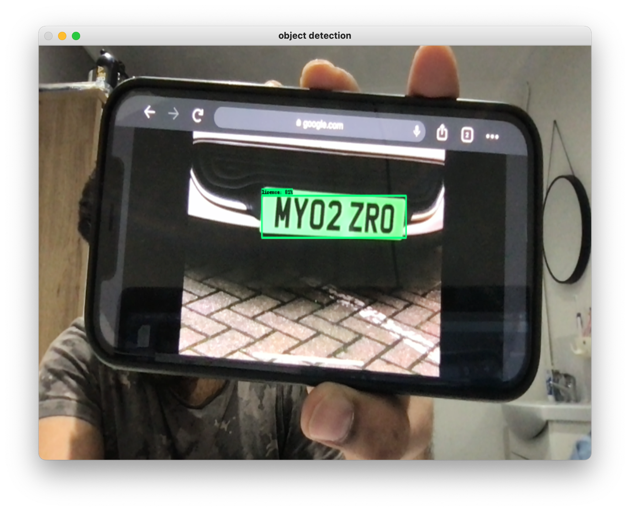

**5] GitHub link –**

https://github.com/abhishekbhandare/Automatic-Number-plate-Detection.git